Join the BLack student Union
We are having our first interest meeting:
When
Wednesday, November 7, 2018 &
Wednesday, November 14, 2018

12p.m. – 12:50p.m. on both dates
Where
Building 9 Room 134
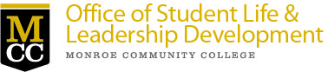
Brighton Campus

