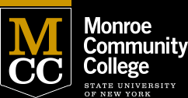
DOWNTOWN CAMPUS
321 State Street, Rochester, New York 14608
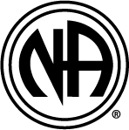
NARCOTIC ANONYMOUS MEETING
WEDNESDAYS
12:00 TO 1:00
ROOM 408
Information about Narcotics Anonymous:
The Basic Text, Narcotics Anonymous, provides the best description of NA:“NA is a nonprofit fellowship or society of men and women for whom drugs had become a major problem. We are recovering addicts who meet regularly to help each other stay clean.” The Twelve Steps of NA are the basis of our recovery program. Our meetings are where we share recovery with one another.
NA is not a part of or connected to any other group, organization, or institution. To respect the anonymity of all of our members, we ask that people who attend our meetings not talk about who our members are or what they share in meetings.

Updated 10/4/19

