Healthy Pizza Party

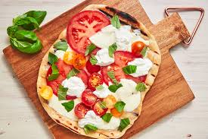

Brought to you by the
5K Walk/Run for Scholarships Wellness Program

Have you ever grilled a pizza? Do you want to learn how? Explore transforming your favorite pizza dinner into a tasty healthy option while showcasing the season’s fresh vegetables. Join the Hospitality Department’s Chef Douglas in this In-Person and Hands-On cooking demonstration and cooking class to learn more.

Who? This event is open to all MCC employees

What? The Menu includes Summer Vegetable Grilled Pizza on Whole Wheat Crust

When? Wednesday August 11, 2021 from 5:00 p.m. to 6:00 p.m.

Where? MCC Hospitality Department kitchen: Building 3 Room 140

How? How much does it cost? The cooking class is FREE (thanks to the 5K
Walk/Run for Scholarships Wellness Program!)

Seating is limited to 15 participants and is on a first come, first served basis, so sign up early. Email Andrea Wolff at awolff@monroecc.edu for additional details and to register for the class.

For your safety in the kitchen, please wear covered-toed shoes with non-slip bottoms. Tennis shoes/sneakers are great! Note that Masks are required.

