Applying for Financial Aid

To complete the easy and self-explanatory financial aid applications for the 2013-2014 academic year:

File it on your own at | Financial Aid Applications | MCC  School Code
www.fafsa.gov | FAFSA  Federal Aid | 002872
www.hesc.ny.gov | TAP  NY State Aid | 2180

You may need the following documentation to complete the financial aid applications:

- Student’s 2012 Federal and New York State Tax Return

- If you are a dependent student, Parents’ 2012 Federal and New York State Tax Return if you are under 22 years of age.

- You need to know the total amount of untaxed income received in 2012. If you, your spouse, or your parents (if applicable) received any untaxed income during 2012, such as child support you need report it in the financial aid application.
Workshop Locations

Or, attend a workshop in the following sites.

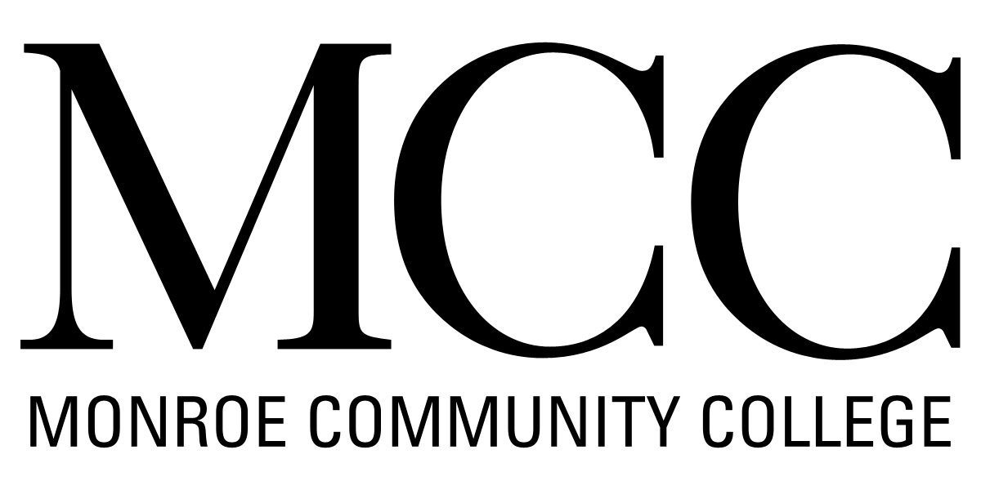
Damon City Campus
Student Services – 5th Floor

Brighton Campus
Building 7 Room101
Free Parking in Lot J during workshop hours
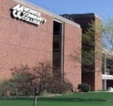
Applied Technology Center
2485 West Henrietta Rd Room 142
Free parking

Food or children are not allowed in the workshops.
Workshops begin promptly at the time indicated.
There will be additional workshops next month.
In addition in the workshop, you can:

- Complete the Federal Student Loan Counseling and Sign the Loan Master Promissory Note at
https://studentloans.gov/myDirectLoan/index.action

APRIL 2013 - Workshop Schedule
Monday | Tuesday | Wednesday | Thursday | Friday
1  Spring Break | 2  Damon City Campus  10:00 am – 12:00 pm | 3  Brighton Campus  2:30 pm – 3:30 pm | 4  Brighton Campus  2:30 pm – 3:30 pm | 5  Brighton Campus  2:30 pm – 3:30 pm
8  Applied Tech. Center  11:30 am-12:30 pm | 9  Damon City Campus  10:00 am – 12:00 pm | 10  Applied Tech. Center  11:30 am-12:30 pm | 11 | 12
15  Applied Tech. Center  11:30 am-12:30 pm | 16  Damon City Campus  10:00 am – 12:00 pm | 17  Applied Tech. Center  11:30 am-12:30 pm | 18 | 19
22  Applied Tech. Center  11:30 am-12:30 pm | 23 | 24  Applied Tech. Center  11:30 am-12:30 pm | 25 | 26
29  Applied Tech. Center  11:30 am-12:30 pm | 30

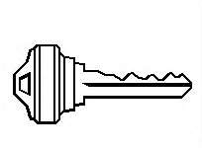
Please come prepared to the
Financial Aid Office. Don't assume
that we know what you need or want.
The IRS Data Retrieval Tool allows students and parents to transfer
the IRS tax return information directly into their FAFSA from the IRS Web site.
“One may walk over
the highest mountain
one step at a time”

