Make MCC Sweeter.
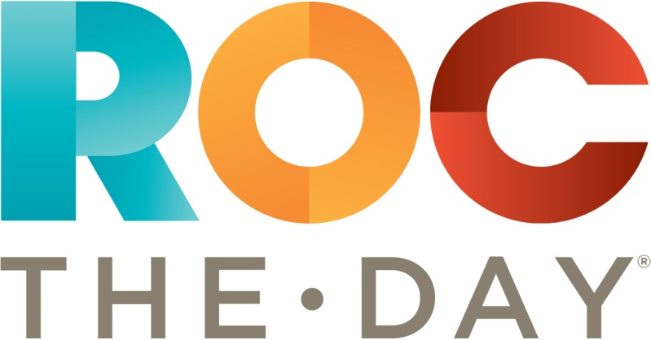
Lake Champlain Chocolate $12.00
In support of the MCC Foundation

