Diversity Council
CDO
Diane M. Cecero

Co-chair
Charlotte Downing

Interim
Co-chair
Christopher Otero-Piersante

Carol Adams

Patrick Bates

Shirley
Batistta-Provost

Carol Battles

Donald Beech

Robert DeFelice

Marlene Fine

Ann Marie John

Peggy
Harvey-Lee

Fred McCullough

Karen Morris

Emeterio M. Otero

Donna Pogroszewski

Craig Rand

JoAnn Santos

Bess Watts

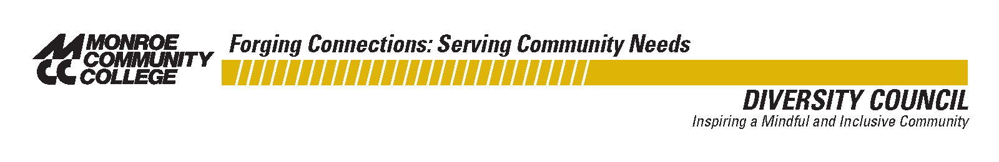

ICE CREAM SOCIAL

“Celebrating Diversity”

To: Diversity Council
Strategic Direction Committees

From: Diane M. Cecero, CDO
Charlotte Downing, Co-Chair
Christopher Otero-Piersante, Co-Chair

Date: Thursday, June 4, 2009

Time: 1:30 pm – 2:30 pm

Place: Gilman Lounge

Refreshments: Make Your Own Sundaes

Thank you to the Diversity Council team and the Strategic Direction Committees for all your contributions to “Celebrating Diversity” this year. We hope to see you at the Ice Cream Social.

