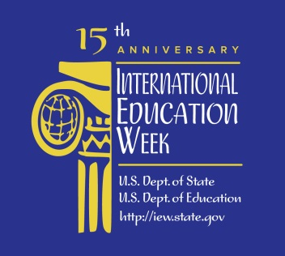

MCC LIBRARIES RESOURCES FOR GO GLOBAL IN YOUR FUTURE!

Websites:

- 65 Study Abroad Grants and Scholarships: http://www.gooverseas.com/blog/65-study-abroad-grants-and-scholarships
- Go Overseas (find programs and read reviews for study, volunteer, teach, and intern abroad programs and language schools abroad): http://www.gooverseas.com/
- International Scholarships & Fellowship Directory: http://www.diversityabroad.com/international-scholarships
- SUNY Frequently Asked Questions: Study Abroad: http://tinyurl.com/nt6h9oe (Note: URL due to change soon)
- SUNY Global - Office of International Programs (including 2014 Study Abroad Guide): http://tinyurl.com/nbvdqnr
- SUNY International Programs search page: http://www.sunysystemabroad.com/

MCC Libraries Resources and Other Resources:

Balaban, Mariah, and Jennifer Shields. Study Away: The Unauthorized Guide to College Abroad. New York: Anchor Books, 2003. Print. - LeRoy V. Good Library (3rd floor) - LB2376 .B33 2003

Benjamin, Medea, and Miya Rodolfo-Sioson. The Peace Corps and More: 175 Ways to Work, Study, and Travel at Home & Abroad. Updated expanded ed. San Francisco: Global Exchange, 1997. Print. - LeRoy V. Good Library (3rd floor) - HN49.V64 B46 1997

Berdan, Stacie Nevadomski. “Busting the Top 10 Study Abroad Myths.” The Blog. 30 Oct. 2013. Web. 10 Nov. 2014. <http://tinyurl.com/nj3ftud>.

Byram, Michael, and Anwei Feng, eds. Living and Studying Abroad: Research and Practice. Clevedon: Multilingual Matters, 2006. Ebrary. Web. 7 Nov. 2014. <http://tinyurl.com/n4ek7wm>.

Camenson, Blythe. Opportunities in Teaching English to Speakers of Other Languages. Rev. ed. New York: McGraw-Hill, 2007. Print. - LeRoy V. Good Library (currently in the International Education Week display on the main floor; later on 3rd floor) - PE1128.A2 C32 2007

Haynie, Devon. “Study Abroad as a Community College Student.” U.S. News & World Report: Education. 25 June 2014. Web. 10 Nov. 2014. <http://tinyurl.com/okkxbof>.

Lyons, Kevin D., and Stephen Wearing, eds. Journeys of Discovery in Volunteer Tourism: International Case Study Perspectives. Wallingford, UK: CABI, 2008. Ebrary. Web. 7 Nov. 2014. <http://tinyurl.com/mtbfpvl>.

Rymarczyk, Jutta, ed. Foreign Language Learning Outside School: Places to See, Learn and Enjoy. Frankfurt am Main: Peter Lang Edition, 2013. Ebrary. Web. 7 Nov. 2014. <http://tinyurl.com/llh4nr9>.

Wilhelm, Ian. “For a Growing Number of Freshmen, Packing for College Requires a Passport.” Chronicle of Higher Education 3 Sept. 2012. Chronicle of Higher Education. Web. 12 Nov. 2014. <http://tinyurl.com/n4qrdn6>.

