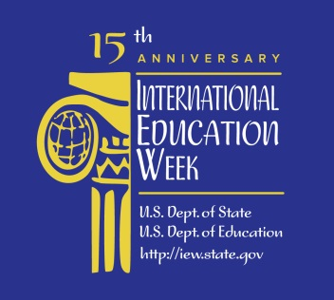

RESOURCES FOR HAWA, THE FILM
Websites:

- Afree Film Production website: http://www.afreefilm.com/
- Arzouma Aime Kompaore’s Dailymotion webpage: http://www.dailymotion.com/Vendredyk
- Hawa, the Film Facebook page: https://www.facebook.com/HawaTheFilm
- Indiegogo fundraising webpage: https://Indiegogo.com/projects/hawa-a-short-by-arzouma-aime-kompaore

MCC Libraries Resources:

African Women Writing Resistance: An Anthology of Contemporary Voices. Eds. Jennifer Browdy de Hernandez et al. Madison, Wis.: University of Wisconsin Press, 2010. Print. - DCC Learning Commons - City PL8011 .A35 2010

Burkina Faso. Petaluma, CA: World Trade Press, 2010. Web. 30 Oct. 2014. <http://tinyurl.com/lyuzelh>.

Encyclopedia of American Immigration. Ed. Carl L. Bankston III. Pasadena: Salem Press, 2010. Web. 30 Oct. 2014. <https://ezproxy.monroecc.edu/login?url=http://www.history.salempress.com>.

Hadley, Craig, and Crystal Patil. "Perceived Discrimination among Three Groups of Refugees Resettled in the USA: Associations with Language, Time in the USA, and Continent of Origin." Journal of Immigrant & Minority Health 11.6 (2009): 505-512. CINAHL Plus with Full Text. Web. 30 Oct. 2014. <http://tinyurl.com/jvv8lmm>.

I Dare to Say: African Women Share Their Stories of Hope and Survival. Ed. Hilda Twongyeirwe. Chicago: Lawrence Hill Books, 2012. Web. 30 Oct. 2014. <http://tinyurl.com/lk7frww>.

Kompaore, Arzouma Aime Nameebroogo. “Hawa.” MFA thesis. Rochester Institute of Technology, 2013. Web. 4 Nov. 2013. <http://scholarworks.rit.edu/cgi/viewcontent.cgi?article=7405&context=theses>.

The New African Diaspora. Ed. Isidore Okpewho and Nkiru Nzegwu. Bloomington: Indiana UP, 2009. Web. 30 Oct. 2014. <https://ezproxy.monroecc.edu/login?url=http://site.ebrary.com/lib/monroecc/Doc?id=10331699>.

Ngazimbi, Evadne E., et al. "Marital Expectations and Marital Satisfaction between African Immigrant and United States Born Married Couples." Journal of Psychology in Africa 23.2 (2013): 317-321. Academic Search Complete. Web. 30 Oct. 2014. <http://tinyurl.com/mmjqkdw>.

Pearce, Susan C., Elizabeth J. Clifford, and Reena Tandon. Immigration and Women: Understanding the American Experience. New York: New York University Press, 2011. Print. - LeRoy V. Good Library (3rd floor) - JV6602 .P43 2011

Roberts, Steven V. From Every End of this Earth: 13 Families and the New Lives They Made in America. New York: Harper, 2009. Print. - LeRoy V. Good Library (3rd floor) - JV6456 .R63 2009

Vigdor, Jacob L. From Immigrants to Americans: The Rise and Fall of Fitting in. Lanham, Md.: Rowman & Littlefield, 2009. Print. - DCC Learning Commons - City JV6450 .V54 2009

