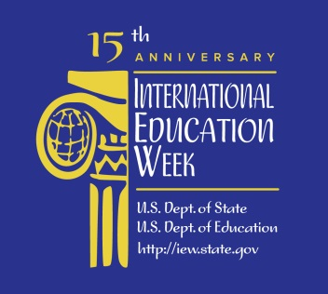

MCC LIBRARIES RESOURCES FOR UNITING AND DIVIDING: HOW RELIGION AND POLITICS ARE AFFECTING EVENTS IN THE MIDDLE EAST

"10 Things You Need to Know about the Middle East." New York Times Upfront 145.1 (2012): 18-21. Education Source. Web. 4 Nov. 2014. <http://tinyurl.com/kkmjpb5>.

Amin, Samir. The People’s Spring: The Future of the Arab Revolution. Nairobi: Pambazuka Press, 2012. Print. LeRoy V. Good Library (3rd floor) - JQ1850.A91 A45 2012

Bishārah, Marwān. The Invisible Arab: The Promise and Peril of the Arab Revolution. New York: Nation Books, 2012. Print. - LeRoy V. Good Library (3rd floor) – JQ1850.A91 B58 2012

Cochran, Judith. Democracy in the Middle East: The Impact of Religion and Education. Lanham, Md.: Lexington Books, 2011. Print. - Damon City Campus Learning Commons - City JQ1758.A91 C63 2011

Gerges, Fazawa. "The Islamist Moment: From Islamic State to Civil Islam?" Political Science Quarterly 128.3 (2013): 389. MasterFILE Premier. Web. 4 Nov. 2014. <http://tinyurl.com/prh7aw4>.

Gerson, Michael, et al. "Faith or Fanaticism?: A Dialogue on the Problem and Promise of Faith in the Middle East." Review of Faith & International Affairs 8.3 (2010): 3-12. Academic Search Complete. Web. 4 Nov. 2014. <http://tinyurl.com/lufovje>.

Haivry, Ofir. "Shifting Alliances in the Middle East: A Political Order Has Passed into History, and a Handful of Coalitions Are Fighting for the Future." Commentary 138.3 (2014): 29+. Academic OneFile. Web. 4 Nov. 2014. <http://tinyurl.com/l7dj6h7>.

Hashemi, Nader. "Rethinking Religion and Political Legitimacy across the Islam–West Divide." Philosophy & Social Criticism 40.4/5 (2014): 439-447. Web. 4 Nov. 2014. <http://psc.sagepub.com/content/40/4-5/439.full.pdf+html>.

Krämer, Gudrun. "Modern but Not Secular: Religion, Identity and the Ordre Public in the Arab Middle East." International Sociology 28.6 (2013): 629-644. Web. 4 Nov. 2014. <http://tinyurl.com/nxq8wyx>.

Miller, Debra A. , ed. Politics and Religion. Detroit: Greenhaven Press, 2013. Print. - LeRoy V. Good Library (3rd floor) - BL65.P7 P6377 2013

"The Power of Religion: Political Islam." The Economist 13 July 2013: 8(US). Infotrac Newsstand. Web. 4 Nov. 2014. <http://tinyurl.com/kdfc2ee>.

Selvik, Kjetil, and Stig Stenslie. Stability and Change in the Modern Middle East. London: I.B. Tauris, 2011. Ebrary. Web. 4 Nov. 2014. <http://tinyurl.com/lceglu8>.

Walker, Christopher J. "Friends or Foes?: The Islamic East and the West." History Today 57.3 (2007): 50-57. Humanities Source. Web. 4 Nov. 2014. <http://tinyurl.com/mhunrt6>.

