To complete the easy and self-explanatory financial aid applications:

FAFSA

File it on your own at
www.fafsa.gov

MCC FAFSA
School Code
002872

TAP

File it on your own at
www.hesc.ny.gov

MCC TAP
School Code
2180

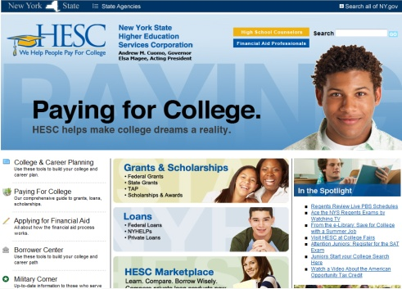

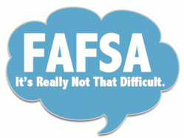

It is easy to file the FAFSA!

