MCC’s 5th Annual Geography Awareness Week Quiz
G.A.W. 2010: Freshwater
Physical Geography
- Freshwater is necessary for life. How much of the earth’s water is fresh? What accounts for the vast majority of world water use?
  - 2.5 percent; farming and ranching
  - 10 percent; drinking water
  - 30.5 percent; industrial
  - 50 percent; drinking water

- As the earth’s temperature rises, climate extremes may become more common. Which of the following has been linked to climate change?
  - Droughts
  - Flooding
  - Melting ice caps
  - Thawing permafrost
  - All of the above

- The highest and largest region on earth supplies nearly a third of the world’s population. Unprecedented warming is causing over 90% of its monitored glaciers to decrease in mass. It is also known as the third pole. Where is the largest volume of ice outside the polar regions?
  - South Island, New Zealand
  - Andes Mountains, South America
  - Rocky Mountains, U.S.
  - Tibetan Plateau, Asia

- What percentage of Earth’s freshwater is locked in ice? This includes ice sheets, glaciers, permafrost, and permanent snow cover.
  - 10
  - 35
  - 50
  - 75

- As rising air temperatures melt ice caps and glaciers around the world, which South American city could see its water supply disappear by the end of the century? This city relies on the Quelccaya ice cap for its summer water. The Quelccaya ice cap is currently melting at a rate in which it will be gone by the year 2100.
  - Caracas, Venezuela
  - Quito, Ecuador
  - Cusco, Peru
  - Buenos Aires, Argentina

- Rochester, NY averages approximately 33 inches of precipitation a year (this includes melted snow). One of the world’s wettest locations(if not the wettest) averages over 450 inches of precipitation a year. This region has been used in many films, including Jurassic Park. Where is this wet location?
  - Kathmandu, Nepal
  - Hong Kong, China
  - Atacama, South America
  - Mt. Waialeale, Kauai, Hawaii
  - Amazon rainforest, South America

- In some areas of this desert, there has been no precipitation recorded for over ten years. It was recently in the news as many miners were successfully rescued. It receives very little precipitation as a result of sinking air (subsidence) and the cool current off of its coast. The driest location on earth is the:
  - Atacama desert, South America
  - Sahara desert, Africa
  - Sonora desert, North America
  - Great Victorian Desert, Australia

- Land that remains frozen year round is known as permafrost. As earth’s temperature warms, some permafrost is thawing and releasing greenhouse gases into the atmosphere. Billions of tons of what compound are stored in Earth’s permafrost?
  - Ozone
  - Gold
  - Oxygen
  - Carbon dioxide
  - Nitrogen

- The largest ocean occupies a third of earth’s surface and reaches depths of more than 35,000 feet (10900 meters) below sea level. The largest freshwater lake by volume is fed by 330 rivers, plunges over a mile deep (1620 meters), and has more than 1500 animal species, most of which are unique to this lake. The largest freshwater lake by surface area is home to the crew of the SS Edmund Fitzgerald after it sunk in waves over 30 feet. What is the largest ocean (by volume), freshwater lake by volume, and freshwater lake by surface area?
  - Atlantic; Titicaca, South America; Ontario, North America
  - Pacific; Baikal, Russia; Superior, North America
  - Indian; Victoria, Africa; Michigan, North America
  - Arctic; Tahoe, North America; Ontario, North America

- Lake Ontario takes much longer to cool down in the fall compared to the air temperature because water has a ____ specific heat capacity. As colder air moves over this relatively warmer water, it creates an unstable environment, leading to cloud growth and ______________.
  - high; lake effect precipitation
  - low; lake oasis effect
  - high; orographic precipitation
  - low; convective precipitation

Human Geography
- The World’s current population is approximately 6.8 billion. According to the World Health Organization, approximately _____ people lack access to safe drinking water and _____ peoplelack access to basic sanitation.
  - 250 million, 750 million
  - 500 million, 1.25 billion
  - 750 million, 2 billion
  - 1 billion, 2.5billion

- Geographers’ understand that the need to walk for clean water is a geographic inefficiency and hindrance to development. How far on average do people (usually women) in developing countries have to walk in order to reach clean water?
  - 1.7 miles
  - 3.7 miles
  - 5.7 miles
  - 7.7 miles

- On average, people living in Sub-Sahara Africa use _____ of water a day. This is the lowest average daily use in the world.
  - less than 1 gallon
  - 1-2 gallons
  - 3-5 gallons
  - 6-8 gallons

- The United States’ current population is approximately 310 million.99% of American homes have indoor plumbingand 90% of Americans get their water from an EPA regulated publicdrinking water system. How much water does the average American use every day?
  - 0-99 gallons
  - 100-199 gallons
  - 200-299 gallons
  - 300-399 gallons

- Nearly _____ of the water a typical American homeowner pays for is never even used—it simply goes down the drain.
  - 5%
  - 10%
  - 15%
  - 20%

- The Ogallala Aquifer, which spans parts of eight states from southern South Dakota to northwest Texas, is steadily being depleted. The Ogallala provides 30 percent of the groundwater used for irrigation in the U.S., and as of 2005, a volume equivalent to _____of the water in Lake Erie had been depleted.
  - one-third
  - one-half
  - two-thirds
  - all

- Beef cattle need approximately _____ gallons of water to supply 500 food calories. It takes approximately _____ gallons of water to produce one pair of blue jeans.
  - 1,900, 300
  - 2,900, 1,300
  - 300, 1,900
  - 1,300, 2,900

Geographic Techniques Questions
- As Geographical Information Systems (GIS) becomes easier and widespread, it allows everyone the ability to analyze anything! Choropleth maps provide a relatively easy way to determine spatial patterns. In the choropleth map below, sufficient rainfall, productive soils, and access to the Mississippi River are some of the major factors that determine where this crop is grown. What is the theme of this map? All data mapped as dark = more.
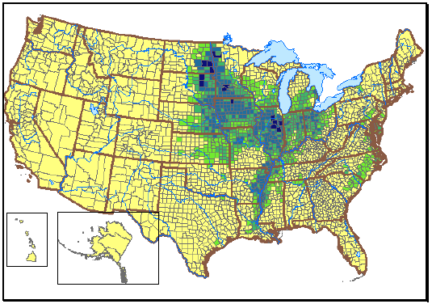
- Cotton acreage
- Soybean acreage
- Tobacco acreage
- Wheat acreage

- GIS falls within a field called geospatial techniques, or the use of technology to analyze anything over space. Another geospatial technique is calledremote sensing. Remote sensing uses images taken above earth to better understand the world. The remote sensing image below is a strategic waterway used by many oil ships. What is the name of this strait (narrow, navigable body of water)?
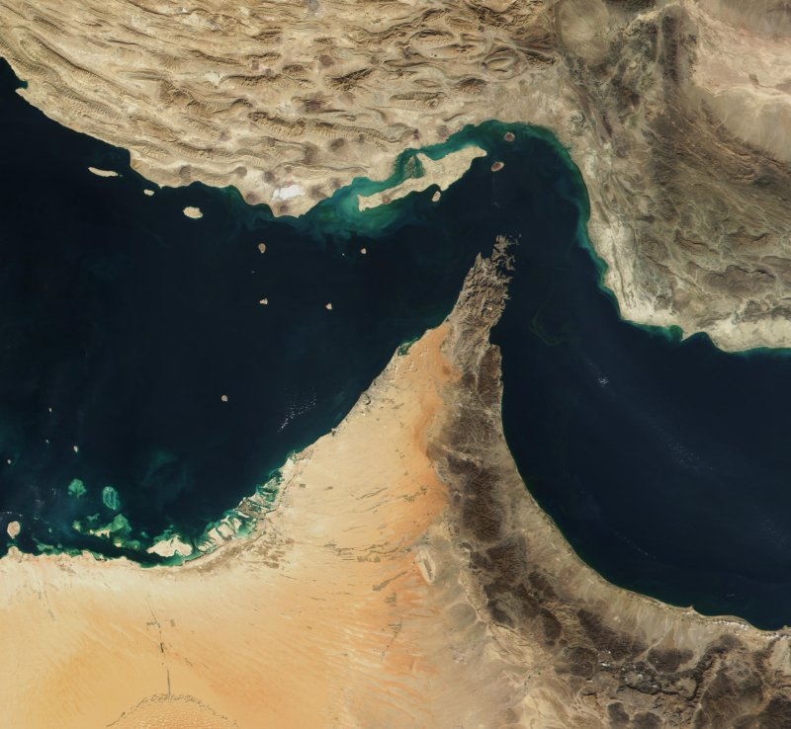
- Strait of Magellan
- Strait of Hormuz
- Strait of Gibraltar
- Cook Strait

- Approximately 69 years ago, this strategic harbor was attacked. What is the name of this harbor?
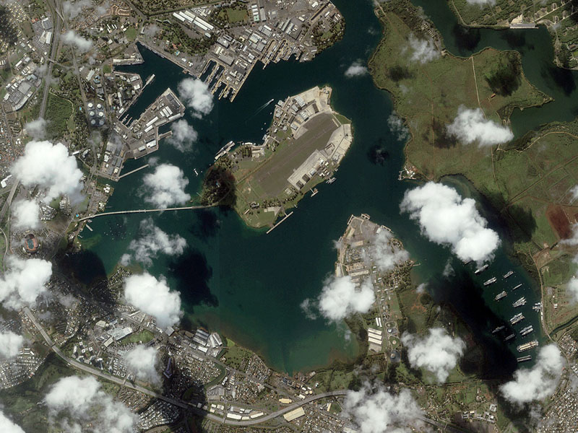
- Port Jackson, Sydney
- Montevideo, Uruguay
- Pearl Harbor, United States
- San Diego Bay, United States

Thanks for taking the 2010 Geography Awareness Week Quiz!

