You may be prompted to perform a hiring approval by an email similar to the one below:
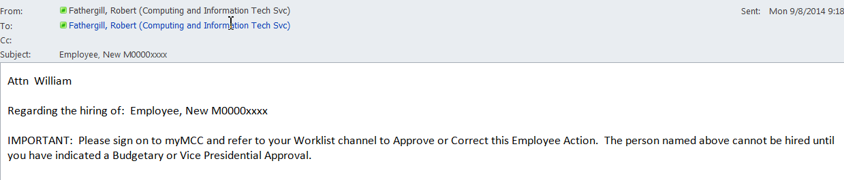

There is a “My Worklist” channel on the Banner tab of myMCC where you will sometimes find lists of approval tasks, such as below.
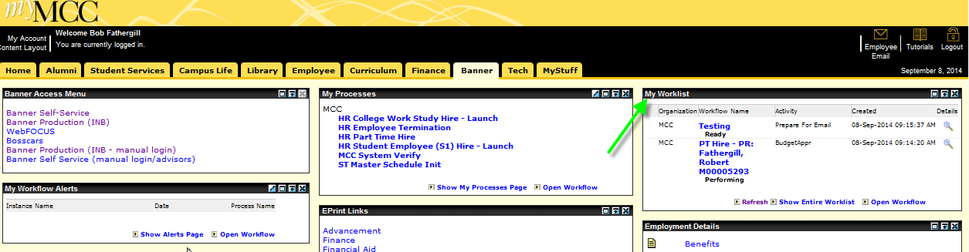

NOTE: Zooming in on My Worklist (below), the red arrows point to the two status values you are likely to see, “Performing” and “Ready”. “Ready” means that no one has yet looked at the item. “Performing” means that someone has clicked on the item and is presumably in the process of reviewing and/or approving it. If you are an Approver, a value of “Performing” most likely means that you yourself have already opened the item at an earlier time and have not yet indicated an Approval, or that one of your Proxies has done so.
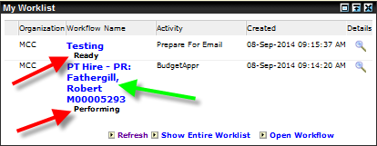
Most of the time when you first encounter one of these worklist items it will be at a Ready status. Having said that, let’s assume that right now you want to review and approve the “PT Hire – PR: Fathergill, Robert M00005293”. To begin, you would click where the green arrow points.

The Budgetary/VP Approval form appears below (in two screen shots).
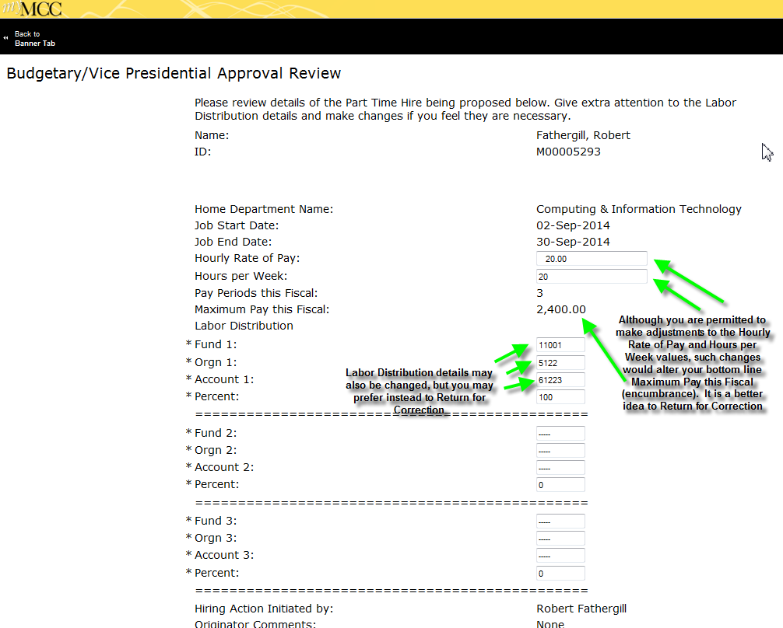
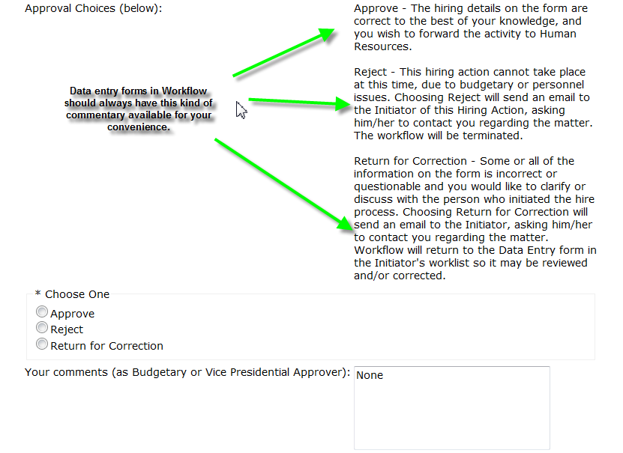
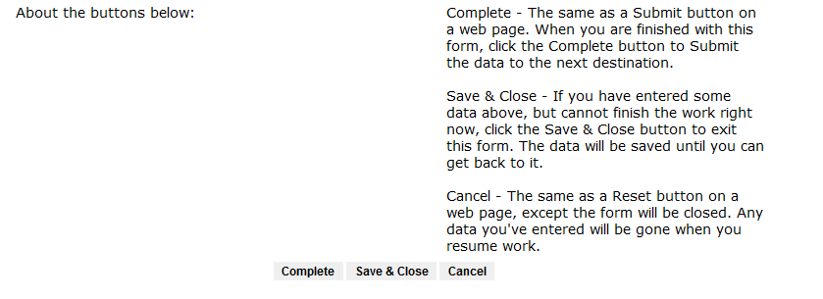
If any other changes need to be made to the details of the hire, you’ll want to enter comments in the “Your comments” box (typing over the default “None” that appears), and choose Return for Correction. If the details are acceptable, you choose Approve and type in some comments if you wish. Click the Complete button to finish your work and move the workflow along.

