**How would you like to be a Fairy Godmother?!**

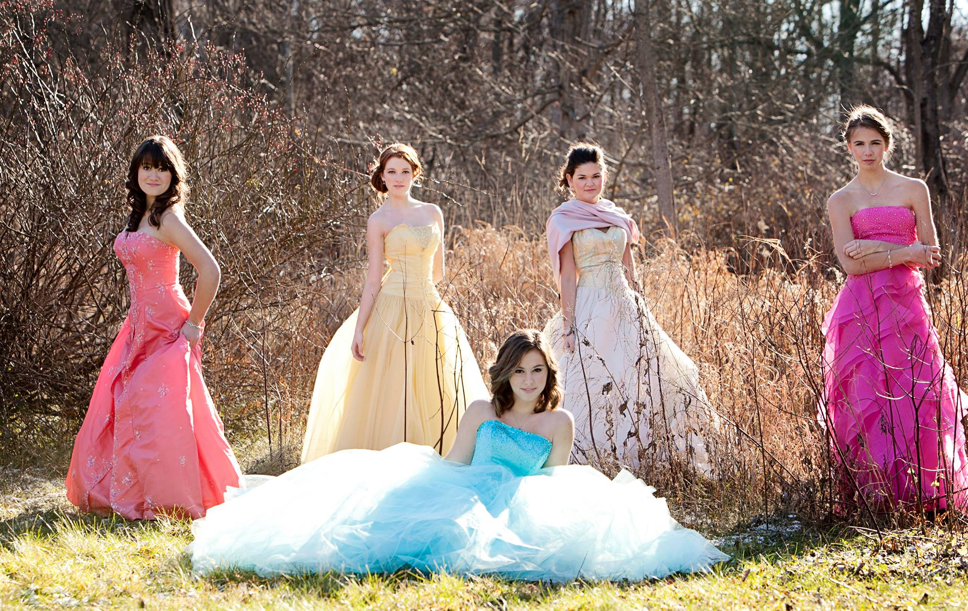**Donate your Prom style dresses to Fairy Godmother’s of Greater Rochester! Your dresses will make another girl’s dreams come true!**

**We will be collecting dresses May 9-13**

**Drop off dresses in room 9-111, the Nursing Department Office**

 cid:image002.png@01D19F97.19F575D0cid:image003.png@01D19F97.19F575D0