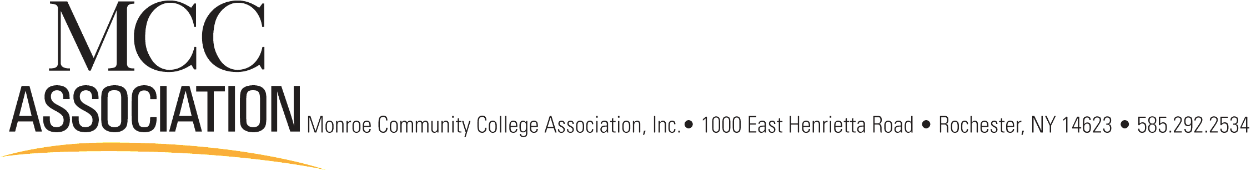
FINANCIAL AID MEAL PLAN CHARGE AGREEMENT/FALL/SPRING 2012/13
Funds Not available until the First Day of Classes

Date_______________ Meal Plan Amount $_______________ (Minimum $25 – Max. $200)

PRINT NAME______________________________ M#______________________________

I hereby authorize Monroe Community College (the “College”) to apply any funds received under Title IV programs towards Meal Plan Charges that are incurred by me per this agreement.

(Title IV INCLUDES: Federal PELL Grant; Federal SEOG; Federal Unsubsidized Stafford Loan; Federal Subsidized Stafford Loan; Federal Parent “PLUS” Loans; and Other Title IV Programs)

I understand that all financial aid reflected on the student account is subject to change until all relevant requirements and documentation are complete and verified.

I understand that if my meal plan payment includes approved financial aid I will be fully obligated to pay the balance of any meal plan as a result of financial aid that does not materialize or for which I am deemed ineligible (as a result of withdrawals, drops, failure to meet academic progress, or other reasons).

I certify that I have been properly registered, have begun classes, and anticipate completing this semester.

I certify that I have received and understand the College and Return of Title IV funds policies set forth in the College Catalogue.

I UNDERSTAND THAT IF I WITHDRAW OR STOP ATTENDING CLASSES
A BALANCE MAY BE OWED TO THE COLLEGE AND MCC ASSOCIATION,
INC. THE BALANCE IS DUE UPON RECEIPT OF THE BILL from the College or the MCC Association, Inc.

ALL BALANCES ARE FORFEITED ON MAY, 30th 2013 . Initials_______ NO CASH REFUNDS!

*Meal Plans cannot be reduced once set-up and cannot be cancelled
*Students are only allowed to add FA funds to Meal Plans twice after initial set-up
*September 24th is the last day to add to Meal Plans from FA for Fall 2012.

*Meal Plan will not be available until 48 hours after agreement is submitted. Please check with a cashier to make sure you have available funds before your first food purchase. Thank you.
Funds not available until First Day of Classes!

Signature__________________________ Date ______________________________

