Example of World Maps Gallery – map, gallery card, QR Code information

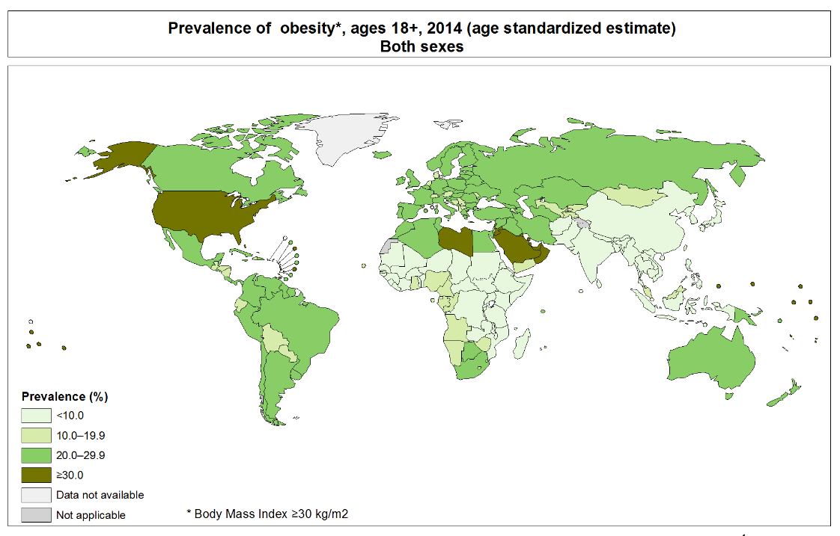
MAP - http://gamapserver.who.int/mapLibrary/Files/Maps/Global_Obesity_2014_BothSexes.png

This map from the World Health Organization shows the prevalence of obesity in men and women over the age of 18. According to the WHO, overweight and obesity are “abnormal or excessive fat accumulation that may impair health.” Many MCC students have grown up in a world that is marked by increasing rates of obesity where almost 40% of adults are overweight and over 10% are obese. Obesity, while preventable, is the result of numerous, layered factors from individual to global economic policies (Johns Hopkins Global Obesity Prevention Center).

Scan QR Code for links to more information

EXAMPLE QR CODE CONTENTS:

Link to a video
How much do we spend on food? https://vimeo.com/14833669
A marketing campaign to fight childhood obesity and sell Technogym products - https://vimeo.com/124522012

Watch a movie via MCC Library’s streaming video service Kanopy –
7 day 2 guys 1 juicer - http://monroecc.kanopystreaming.com/video/7days-2guys-1juicer

Links to additional information
http://www.globalobesity.org/ Advocating a systems approach to solving obesity
http://www.worldobesity.org/resources/ Additional maps highlighting global obesity
http://www.worldobesity.org/resources/calculate-your-bmi/ Calculate your own BMI

Focus questions:
What surprised you about the global obesity map? What was not surprising?
What might a systems approach to solving obesity look like here in Rochester?
What would be your marketing campaign to fight obesity if money and time were no object?
What role does a person’s fears and habits play in the quest to live a healthy life?

