MCC Liberty Partnerships Program Attends Annual Summit in Albany

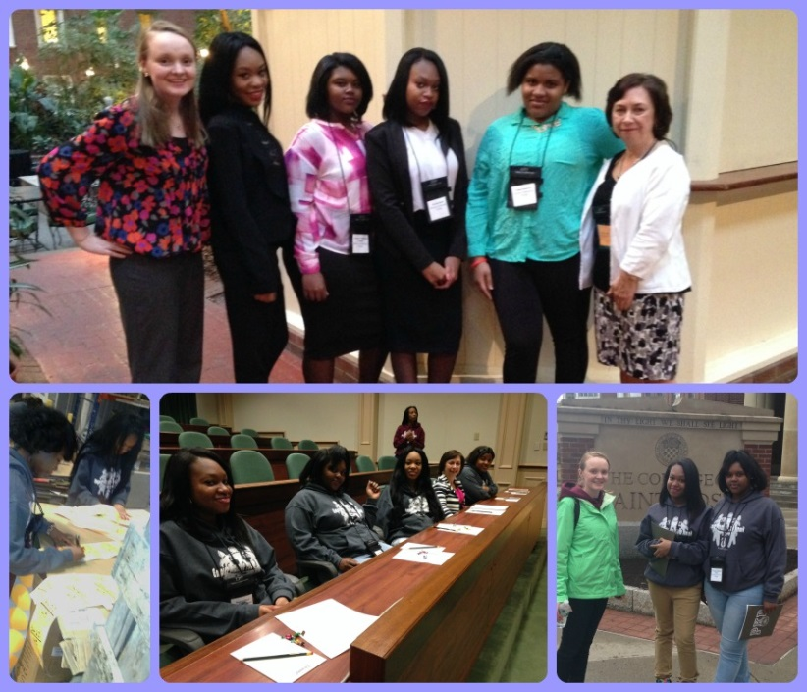
This month, the Liberty Partnerships Program (LPP) selected four students to take to Albany for the annual LPP Empire Promise Youth Summit. The students who attended represented the MCC program, alongside of almost 200 students from 38 other LPP programs across the state.

The LPP students are from the Rochester City School District, and have proven to be strong leaders in the classroom as well as during LPP tutoring and workshops. During the summit, students attended workshops focused on envisioning their dreams, developing leadership skills, understanding of the college application process and leading a healthy lifestyle. The students also had the choice to attend one of two trips in the Albany area. One group visited Schenectady County Community College and then toured the College of Saint Rose. The second group of students joined forces with LPP students and bottled water for communities around New York, and then took a tour of the State Capitol building. The program hosted a dance for the students to celebrate the last night of the summit.

With a successful weekend of growth, networking, and independence behind them, the MCC LPP group returned to Rochester ready to return to their studies and utilize their new and improved leadership skill sets.

MCC’s Liberty Partnerships Program is funded by the New York State Department of Education.

