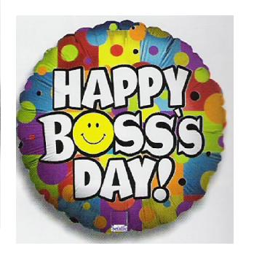
30 percent off – Today and Friday

Thank you cards, socks, Vera Bradley and more…!

