Day Of the Dead  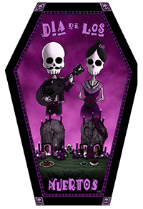 | Join Professor Jorge Alas and Adriana Hoppe as they present the traditions of the Day of the Dead celebration along with a demonstration on the creation of the altar.  When: Monday, October 31, 2016  Where: PRISM (Multicultural Center)  Time: 12:00-12:50 PM  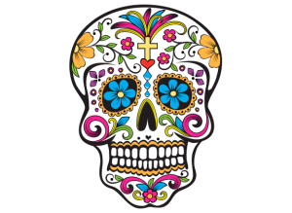
This event is sponsored by the Liberal Arts Division, the World Languages and Cultures Department, Global Education & International Services and Latino Empowerment Network (LEN).

