Please help us welcome Mr. Alan Moncada, faculty from La Universidad Autónoma de La Ciudad Juarez in Mexico. Mr. Moncada is the counter part of Ms. Marisol Galarza-Ruiz as part of the COIL class partnership.
You can meet Mr. Moncada TODAY at the COIL Meet Up gathering (12 p.m. in Career Services library 3-108) as he and Marisol Galarza-Ruiz share about their COIL partnership, the module they designed for their students, and the benefits of intercultural communication – for themselves and their students!
To coincide with his visit and in celebration of Hispanic/Latino Heritage Month, I am featuring Mexico as the country of the week.
México is also one of our top partnering countries for COIL courses taught by our MCC faculty. COIL is a collaborative online international learning where an MCC faculty member works with a professor from another country to design a collaborative module for their students. These COIL courses offer our students first hand interaction with their Mexican peers and a richer understanding of Hispanic heritage.

México
Official name: Estados Unidos Mexicanos = United Mexican States.
Capital: Ciudad de México (México, D.F) = Ciudad de México (México, D.F)
Currency: Peso Mexicano. As of September 28, 2016, the value of $ 1 US dollar is equal to $19.43 Mexican pesos.
Languages: Although Spanish is the official language of México, currently there are approximately sixty-eight languages with their own variations spoke throughout the Mexican territory. Some of these languages are náhuatl, maya, zapoteco, mixteco, otomi, totoneca among others. This means that you might meet someone from México that may not speak Spanish.
The Mexican Flag: The flag is composed of three vertical stripes:
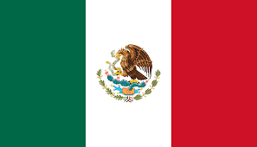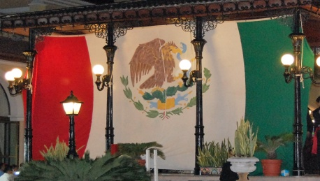

- Green stripe represents hope and victory.
- White stripe represents the purity of Mexican ideals. The white stripe also has the coat of arms and it shows an eagle eating a rattlesnake perched on the nopal (prickly pear) cactus.
- Red stripe: is to remember the bloodshed by the nation’s heroes.

México is located in the southern portion of North America. Its northern border is shared with the United States; the south and west by the Pacific Ocean and Belize, Guatemala and the Caribbean Sea to the southeast.
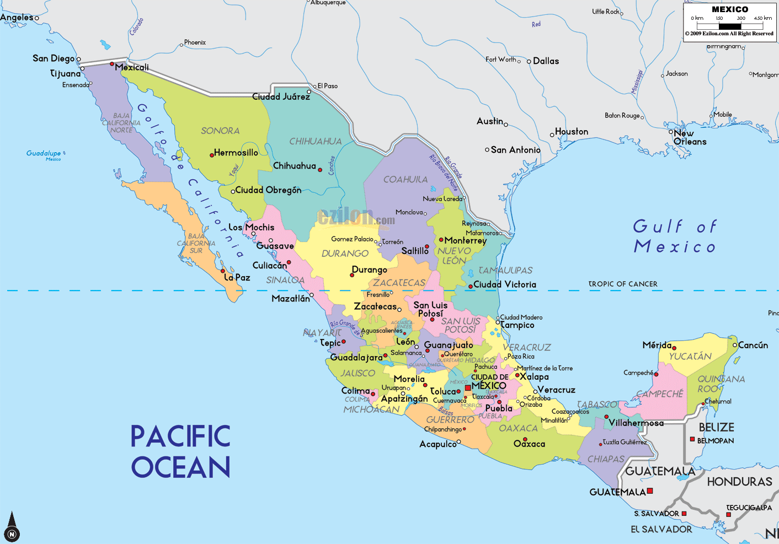
México consist of 31 states and one federal district (most recently is refer to Mexico City). Mexico is the third largest country in Latin America after Brazil and Argentina and holds the largest population of Spanish speakers in the world. The largest Latino group of legal immigrants living in the United States are of Mexican descent. Perhaps this may be due to the Treaty of Peace, Friendships, Limits and Settlement between the United States of America and the Mexican Republic (as it was then known) signed on February 2, 1848. This treaty is also known as The Treaty of Guadalupe Hidalgo and where México ceded California, half of New Mexico, most of Arizona, Nevada, Utah and parts of Wyoming and Colorado to the United States of America. Mexicans were given the choice of relocating within Mexico's new boundaries or receiving American citizenship with full civil rights. Over 90% chose to become U.S. citizens. This is why you may have heard the expression, “We did not cross the border, the border crossed us”
Typical Foods:
The traditional food remains native and derived from corn, beans and chili peppers. However, the Europeans introduced a large number of other foods that comes from domesticated animals such as cow, pork, chicken, goat and sheep. It is also worth noting that depending on the region of Mexico the same food might have a variation of ingredient and possibly even a different taste.
