Certified Pre-Owned NOOK Tablet™ - 16GB $219.99

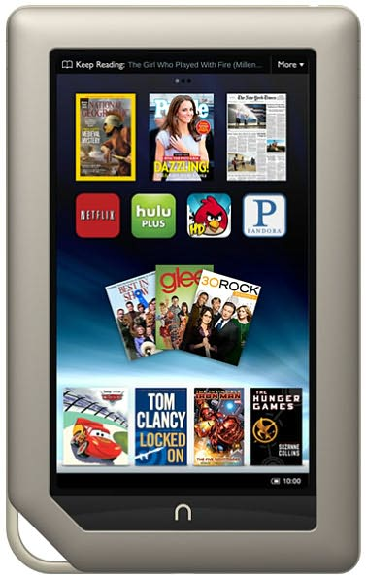

The fastest, lightest, most powerful tablet with the best in reading & entertainment. Movies, TV shows & music from Netflix, Hulu Plus™, Pandora® & moreLightning fast web-browsing, email & smooth streaming video
- World's most advanced VividView™ 7" Touchscreen
- Extra-long battery life—11.5 hrs of reading or 9 hrs of video
- 1GB RAM
- Expandable memory- add up to 32 GB w/ microSD™ card

Available today right in your MCC Bookstore!
- Over 2.5 million books, magazines, comics & kids' books
- Thousands of must-have apps like Angry Birds & Words With Friends
Bottom of Form

