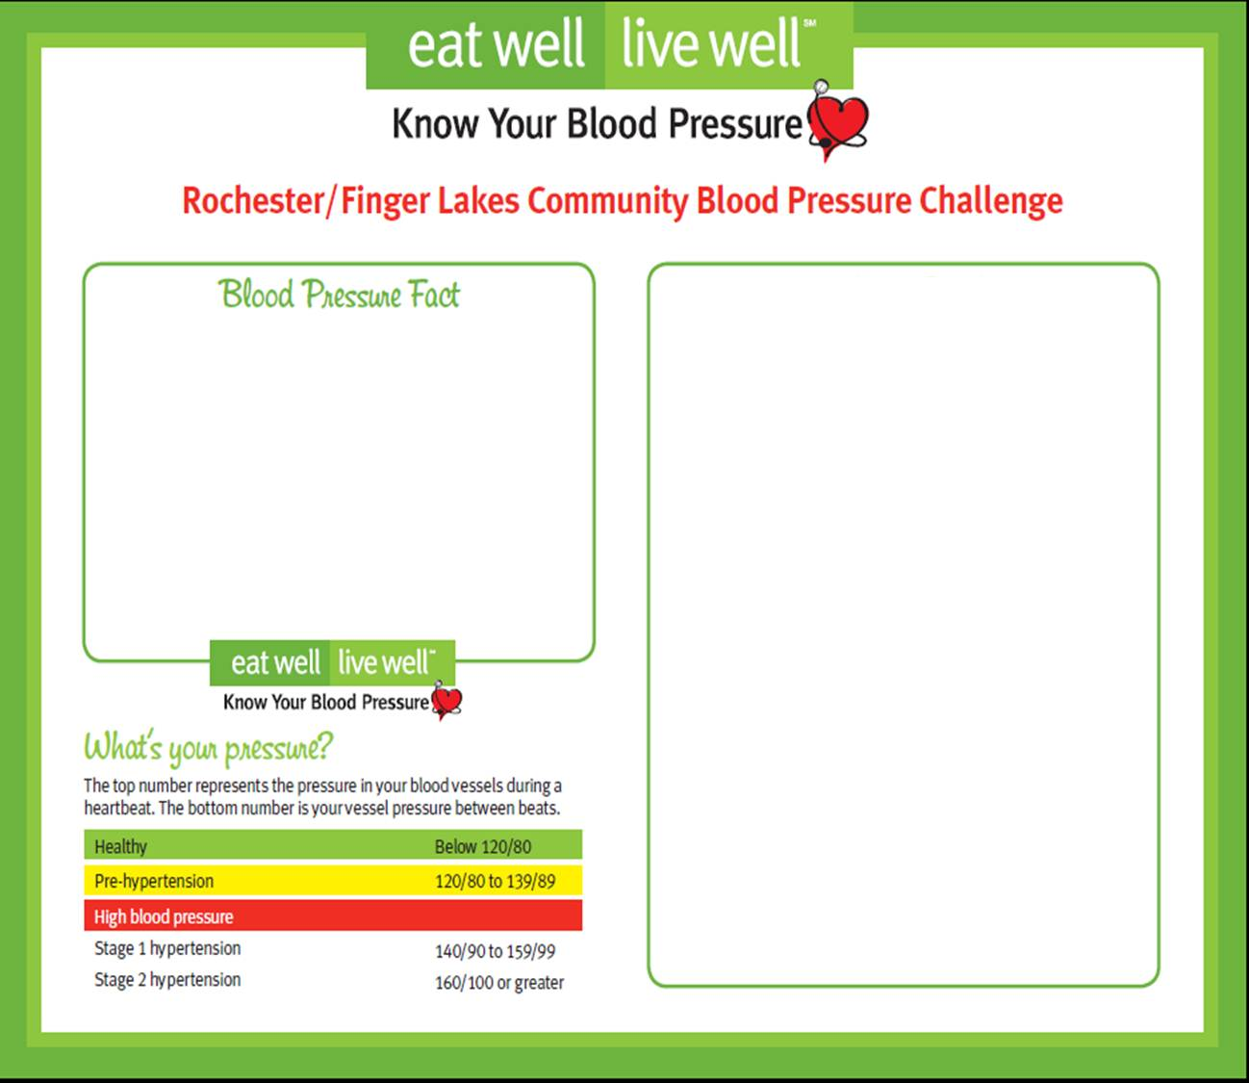

**Get Inspired!**

**Only 12 days until the challenge begins!**

**A Quick Check-Up**

[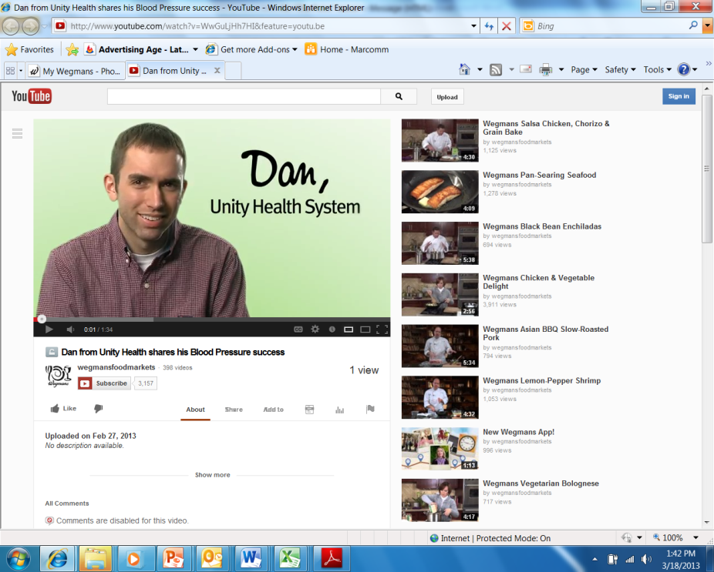](http://youtu.be/WwGuLjHh7HI)

**Did you know?**

*Every 20 point increase in the top blood pressure number doubles your risk of complications from stroke or heart attack*

**Blood Pressure Proclamation Day!**

**“I know my numbers” Poster Campaign**

[**Like us on Facebook!**](https://www.facebook.com/BloodPressureChallenge)

The new [**EWLW.org**](http://www.ewlw.org) is live. You can access the blood pressure toolkit on the site today. You can also enter a “test blood pressure” to see how it works. ***Please note: All blood pressures will be cleared before the March 24th start date.***

 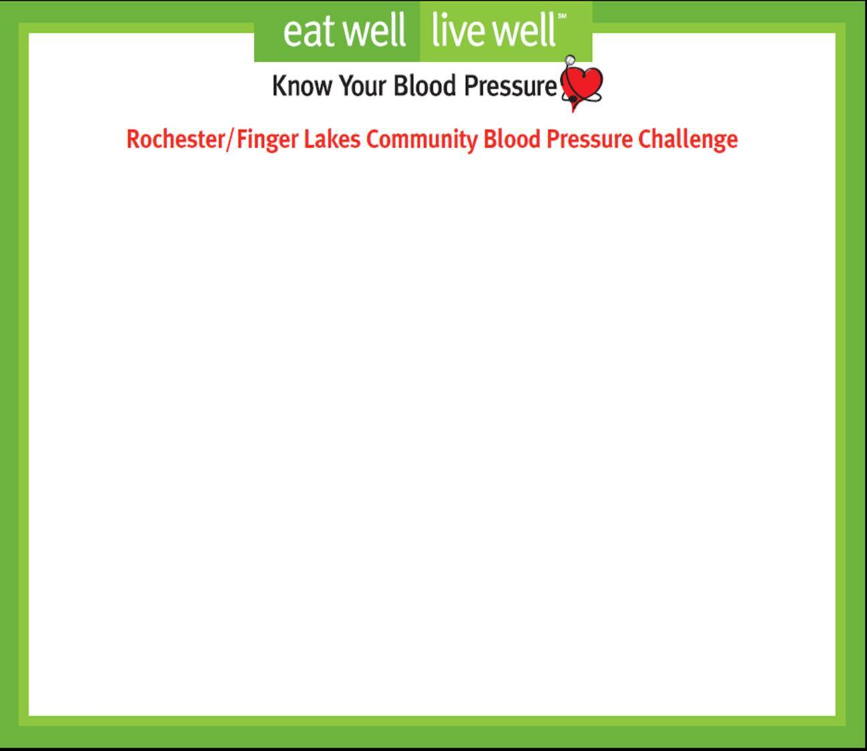

Have you seen Don Alhart? Soon, Rochester will be flooded with “I know my numbers” posters with local community and media celebrities, from Dan Mason, GM of the Rochester Red Wings, to Tony Boler, Radio Host of WDKX-FM, advocating for the Rochester community to know their blood pressure numbers.

**“I know my numbers” Poster Campaign**

Blood Pressure Proclamation Day!

Blood Pressure awareness is critical to the lives of so many. Often coined the “the silent killer”, high blood pressure can lead to heart disease, stroke, and more. That is why, the Mayor of Rochester, Tom Richards, and Monroe County Executive, Maggie Brooks, have agreed to declare March 25th Blood Pressure Proclamation Day! The Mayor and County Executive will hold a joint press conference on March 25th at 10:30 am at the YMCA on E. Main Street. The Mayor and County Executive will be joined by Fran Weisberg, Executive Director of Finger Lakes Health Systems Agency, Danny Wegman, CEO of Wegmans Food Markets, and Sandra Parker, President & CEO of the Rochester Business Alliance. This is an exciting initiative to acknowledge the importance of “Knowing Your Numbers” and a wonderful start to the Blood Pressure Challenge. *Please feel free to attend the press conference and show your support.*