United States Passports

General Passport Information
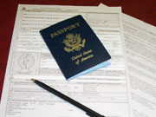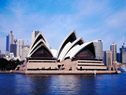

Please be prepared to provide the following:
- A completed application, type written or neatly printed in black or blue ink only. Do not sign the form until in the presence of a Clerk.
- Proof of U.S. citizenship in one of three forms: a certified copy of your birth certificate with a raised seal; original naturalization papers, or an old U.S. passport issued in your name. The birth certificate in either original or certified form must be the long form which contains your full name with correct spelling, parents' names, date and place of birth, file or registration date and a raised seal or other certification marking. Some birth notices and birth registrations do not contain all the relevant information required by the Department of State. Hospital certificates cannot be accepted.
- Proof of identity in the form of a valid NYS Driver License or non-Driver ID, a valid military ID, naturalization papers issued to you as an adult, or an INS Alien Registration Card.
- Two identical passport photos, 2" x 2" with a white background and a full front view of your head and shoulders. Pictures must be taken within the last six months. Pictures are available in the Monroe County Clerk’s Office for a fee of $7 per set.
- $110 cash, check, Visa, MasterCard, Discover or money order payable to “U.S. Department of State” for a passport book and $30 payable to the "U.S. Department of State" for a passport card. There is an additional $25 agency processing fee for each application.
- Applicants between the ages of 16 to 18 must appear with a parent or legal guardian.
- Applicants under the age of 16 must appear with BOTH PARENTS.
Note: If you were born in Monroe County you may obtain a copy of your birth certificate by contacting the Bureau of Vital Statistics at 753-5141. Please be sure to request the long form birth certificate.

