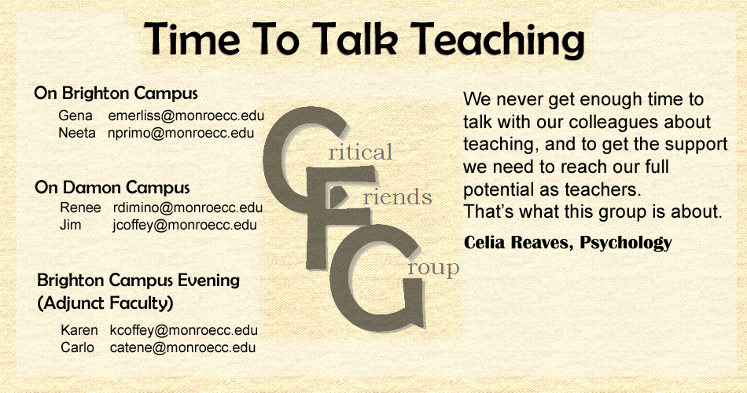

**Is This For Me?**

We could write lots of descriptive stuff here that wouldn't begin to describe how a CFG could benefit you and your teaching. So drop one of us a line and let us speak to you personally.

**When Do You Meet?**

​**Brighton**: Fridays 9:30-11:30am

**Damon**:  Friday afternoons, once each month (specifics will be set to meet those interested)

**Adjunct Evenings**:  Third Tuesdays at 4:00​pm