Global Learning in the Classroom
Faculty Reading Study Group
Spring 2015
How can I infuse a more global perspective in my already jam-packed course?

Why is that important for my students and myself?

Why won’t my “international” students approach me for the help they clearly need?

How can I encourage them to contribute more to classroom discussions?

In this group, we will use a selection of articles, essays, and book chapters to explore a range of themes related to developing global awareness and intercultural competence in the classroom. This program is open to both adjunct and full-time faculty and is co-sponsored by the Teaching & Creativity Center and the Global Education & International Services Office.

Brighton Teaching & Creativity Center (12-201)
Thursdays from 2-3:15

Meeting Dates/Topics:
- January 29th – What is global education? Why is it important? What are the characteristics of a “global learner”?

- February 12th – What is cultural identity? How do differences in values and perceptions across world cultures challenge intercultural communication?

- February 26th – Who are our “international” students at MCC? How do their backgrounds and life experiences differ and what do they bring to our classrooms?

- March 5th – How can we engage international students effectively in the classroom and curriculum? How can we develop intercultural competence in teaching?

- March 19th – What do we mean by “internationalizing” the curriculum, and what are some specific examples of including global concepts in the classroom?

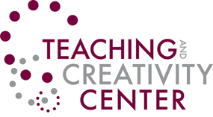
For more information and to RSVP, please contact the co-facilitators:
Don Beech Amanda Colosimo
Academic Support Services Chemistry & Geosciences
dbeech@monroecc.edu acolosimo@monroecc.edu
292-2345 292-2421

