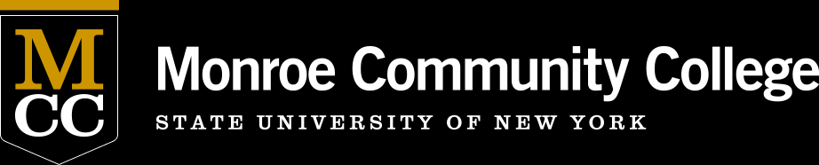
MCC’s one-stop scholarship application available at Scholarships Online!
https://monroecc.academicworks.com/
- Remind students that applying is easy and they may be eligible for awards even if they don’t think they qualify!
- Over 200 Scholarships are available online.
- Thousands of Student Scholarships have been awarded through the system in the last two years.
- Both merit and need based Scholarships are available.
- Encourage all to apply as you interact with students.
- One online application provides access to money for school that students may not be aware of.
Over $1 Million will be awarded to MCC Students this academic year!

