Vote with your thumbs!
Follow the QR code below or go to http://tinyurl.com/nnjyd9a or https://www.facebook.com/mcclibraries/posts/10151996252620064
to view proposed MCC Libraries homepage design #1.
Click on the features you like best. Your vote will be counted with each click!
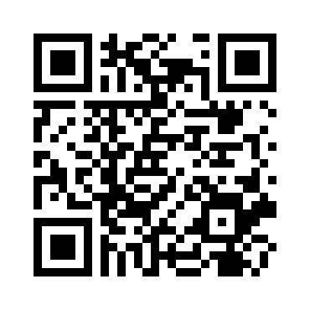
Then - follow the QR code below or go to http://tinyurl.com/ke9w45e or https://www.facebook.com/mcclibraries/posts/10151996252620064
to view proposed MCC Libraries homepage design #2.
Click on the features you like best. Your vote will be counted with each click!
