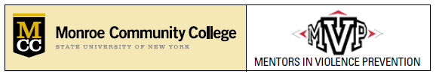

MONROE COMMUNITY COLLEGE
Mentors in Violence Prevention in ACTION
SCHOLARSHIP APPLICATION
Spring 2016

Monroe Community College’s Mentors in Violence Prevention has partnered with MCC’s Foundation and is delighted to announce the availability of a $3,000 scholarship to be awarded to an MCC Student who is returning for the Fall 2015/Spring 2016 School Year.

Eligibility Requirements

- Open to any student enrolled in Monroe Community College that is returning as a FULL-TIME Student (12+ Credit Hours) for the Fall 2016/Spring 2017 School Year.
- Students do not need to have been in the MVP Train-the-Trainer Program Workshop already, but do need to express their commitment to violence prevention.
- Selection of the winners will be decided by the Mentors in Violence Prevention Team and will be based upon the essay review.
  - Other factors that will be taken into consideration include: skill and ability, initiative, eagerness to learn, discretion, maturity, and flexibility.

Essay Topic:

What have I (the student) done and/or plan to do with the principles of MVP Training to impact our community.

Essay Requirements:

- Essay must include:
  - your name,
  - student M#,
  - MCC e-mail address, and
  - a daytime phone number.
- Essay must be between 500 and 1,000 words.
- Essay must be in Times New Roman font size 12. (Double-line spacing is NOT needed.)
- Essay must be submitted electronically -- via Scholarships Online at www.monroecc.edu/go/scholarships/

DEADLINE FOR SUBMITTING SCHOLARSHIP ESSAY:
Friday, April 29, 2016 BY 12:00 PM

