Spring 2015
Introduction to Remote Sensing
GEG 133 (3 credit hours)
Introduction to the fundamentals of Geospatial Technology, with a focus on remote sensing but also including Geographic Information Systems (GIS), global positioning system (GPS), cartography, and spatial analysis. Students will be guided through a series of lectures and hands‐on computer‐based exercises. An end of a semester project will allow students to work on a project of their own design. Course materials used are based upon the United States Department of Labor’s Geospatial Technology Competency Model (GCTM) for entry level geospatial occupations including Geospatial or GIS Technicians or Technologists. Natural science elective and a sustainability elective (GR). This is a lab course.

Prior computer knowledge (ask instructor for permission) or GIS experience (GEG 130 or GEG 211) will be required to be successful in this course.
 | Geology | Land Use  Change

Students in this course:  - Learn the fundamentals of Remote Sensing, map design, and Geography.  - Develop skills necessary to create and acquire remote sensing data and use Global Positioning System to assess accuracy.  - Utilize Geospatial technology (GIS and Remote Sensing) to answer questions.  - Utilize ArcGIS, ENVI, and Pictometry software. | Topics Covered:  - Electromagnetic spectrum  - Spatial and temporal resolution of Landsat data  - Land cover and land use change  - Wildfires  - Supervised vs. unsupervised classification  - ENVI and Pictometry  - Lidar  - Biology/Ag/Climate/Geology applications  - Individual Project
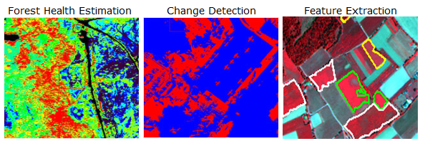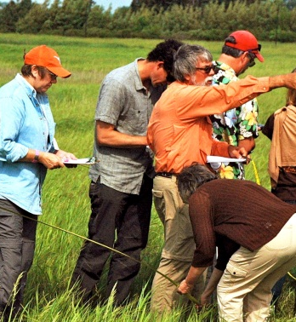
Time: Faculty: Registration
Tue/Th Jonathon Little http://www.monroecc.edu/depts/recreg/howtoreg.htm
12:30-1:50 Email: jlittle@monroecc.edu Email registration@monroecc.edu
Phone 585-292-2396

