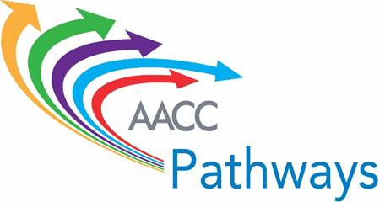

**Transfer and Employment Program Mapping Template**

Use this template to map the relationships between the institution’s programs in a particular meta-major and related jobs and further education opportunities. This template is based on examples from Pierce College, which can be found here: <http://www.pierce.ctc.edu/dept/pathways/>**. Complete the templateyou’re your institution’s top three meta-majors by enrollment.**

This worksheet should be helpful to get started mapping the relationships between programs in a particular meta-major, connected to related jobs and further education opportunities.

***Certificates in this Meta-major Area (1):***

|  |  |  |
| --- | --- | --- |
| Certificates | Associate degree within which the certificate is embedded (if applicable) | Related Job/Career |
|  |  |  |
|  |  |  |
|  |  |  |
|  |  |  |
|  |  |  |
|  |  |  |
|  |  |  |

***Associate Degrees in this Meta-major Area (1):***

|  |  |  |
| --- | --- | --- |
| Associate Degrees | Transfer Pathways to Bachelor’s Degrees (if applicable) | Related Job/Career |
|  |  |  |
|  |  |  |
|  |  |  |
|  |  |  |
|  |  |  |
|  |  |  |
|  |  |  |

***Certificates in this Meta-major Area (2):***

|  |  |  |
| --- | --- | --- |
| Certificates | Associate degree within which the certificate is embedded (if applicable) | Related Job/Career |
|  |  |  |
|  |  |  |
|  |  |  |
|  |  |  |
|  |  |  |
|  |  |  |
|  |  |  |

***Associate Degrees in this Meta-major Area (2):***

|  |  |  |
| --- | --- | --- |
| Associate Degrees | Transfer Pathways to Bachelor’s Degrees (if applicable) | Related Job/Career |
|  |  |  |
|  |  |  |
|  |  |  |
|  |  |  |
|  |  |  |
|  |  |  |
|  |  |  |

***Certificates in this Meta-major Area (3):***

|  |  |  |
| --- | --- | --- |
| Certificates | Associate degree within which the certificate is embedded (if applicable) | Related Job/Career |
|  |  |  |
|  |  |  |
|  |  |  |
|  |  |  |
|  |  |  |
|  |  |  |
|  |  |  |

***Associate Degrees in this Meta-major Area (3):***

|  |  |  |
| --- | --- | --- |
| Associate Degrees | Transfer Pathways to Bachelor’s Degrees (if applicable) | Related Job/Career |
|  |  |  |
|  |  |  |
|  |  |  |
|  |  |  |
|  |  |  |
|  |  |  |
|  |  |  |