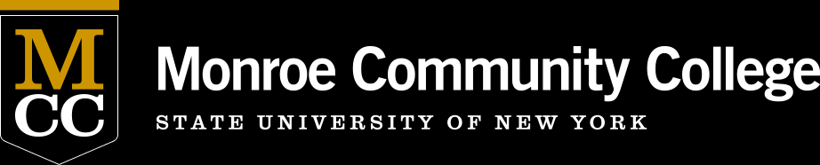

**ALP Explained**

ALP (Accelerated Learning Program) is a new option for students who place just below college-level in reading and writing. Instead of taking a prerequisite class (taking a basic English course one semester, and ENG 101 the next semester), you take ENG 101 **and** TRS 099, which provides extra support for the work you’re doing in ENG 101. This saves you a semester of coursework.

It works like this: you show up for ENG 101, and then go to TRS 099 immediately afterwards. Both classes are taught by the same professor, so you continue to work on your ENG 101 assignments in TRS 099. It is more than a workshop/lab, however. The professor will teach you the skills that ENG 101 expects you to already have, and will help you to better understand your own learning and stay on track with both courses.

If you have questions, please feel free to contact:

**Professor Jim McCusker**

Phone: 292-3140

Email: [jmccusker@monroecc.edu](mailto:jmccusker@monroecc.edu)

**Professor Jacob Bodway**

Phone: 292-3269

Email: [jbodway@monroecc.edu](mailto:jbodway@monroecc.edu)

**Professor Matthew Fox**

Phone: 292-3138

Email: [mfox@monroecc.edu](mailto:mfox@monroecc.edu)

**Please register for both courses in one of the pairs below:**

**Brighton Daytime Courses**

ENG 101-01A (32719) MWF 9-9:50 AM +

TRS 099-01A (33303) MWF 10-10:50 AM

ENG 101-02A (23743) MWF 9-9:50 AM +

TRS 099-02A (33307) MWF 10-10:50 AM

ENG 101-03A (32793) MWF 1-1:50 PM +

TRS 099-03A (33306) MWF 2-2:50 PM

ENG 101-04A (20320) MWF 1-1:50 PM +

TRS 099-04A (33305) MWF 2-2:50 PM

ENG 101-05A (32794) Tuesday/Thursday 9:30-10:50 AM +

TRS 099-05A (33312) Tuesday/Thursday 11 AM -12:20 PM

ENG 101-07A (32792) Tuesday/Thursday 12:30-1:50 PM +

TRS 099-07A (33313) Tuesday/Thursday 2-3:20 PM

**Brighton Evening Course**

ENG 101-83A (32795) Tuesday/Thursday 5:30-6:50 PM +

TRS 099-83A (33311) Tuesday/Thursday 7-8:20 PM

**Downtown Campus**

ENG 101-C3A (30140) MW 9-10:20 AM +

TRS 099-C3A (33309) MW 10:30-11:50 AM

ENG 101-C4A (32799) Tuesday/Thursday 11 AM – 12:20 PM +

TRS 099-C4A (33304) Tuesday/Thursday 12:30-1:50 PM

**Online**

ENG 101-SLA (32800) +

TRS 099-SLA (33310)

ENG 101-SLX (20410) +

TRS 099-SLX

**ALP Courses Spring 2019**