Clear Browser Cache: FIREFOX

Click on hamburger menu, go to Settings:
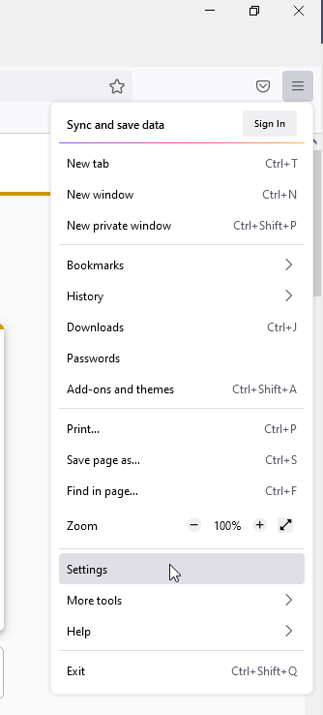

Go to Privacy and Security, scroll down to “Cookies and Site Data”
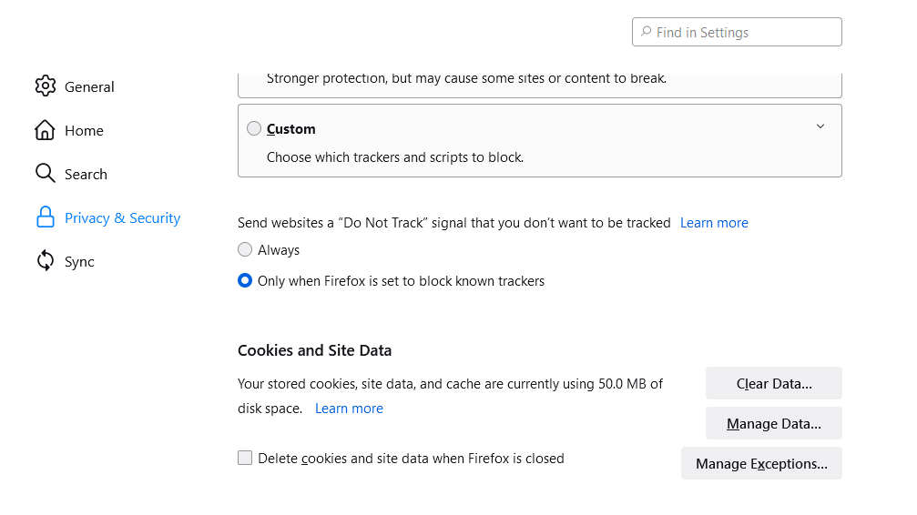
Click on Clear Data….
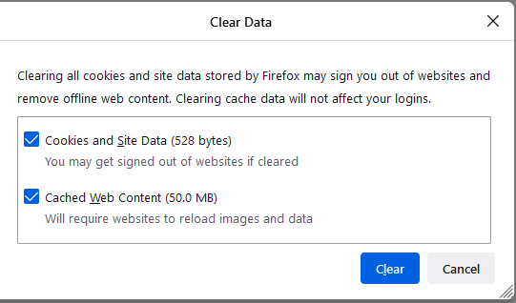
And click Clear. Another box will pop up to confirm.
Close your browser and open a new session.

Clear your browser cache: CHROME
Click on the vertical ellipsis menu and go to Settings:
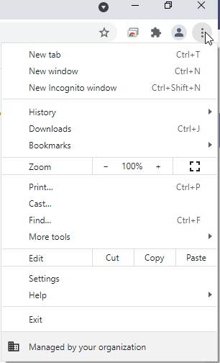
Go to Privacy and Security, “Clear browsing data”
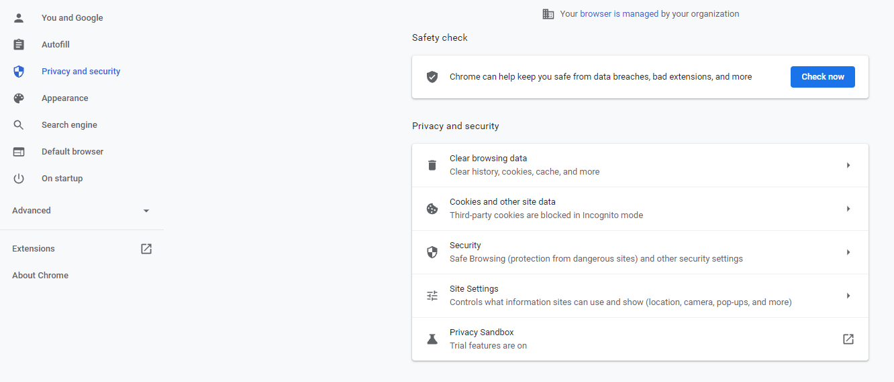
Click “Clear data” – make sure the time range is set to “all time”:
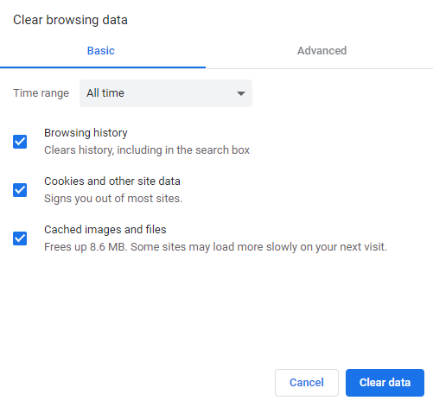
Close your browser and open a new session

