Healthy Indian Curry & Okra Party

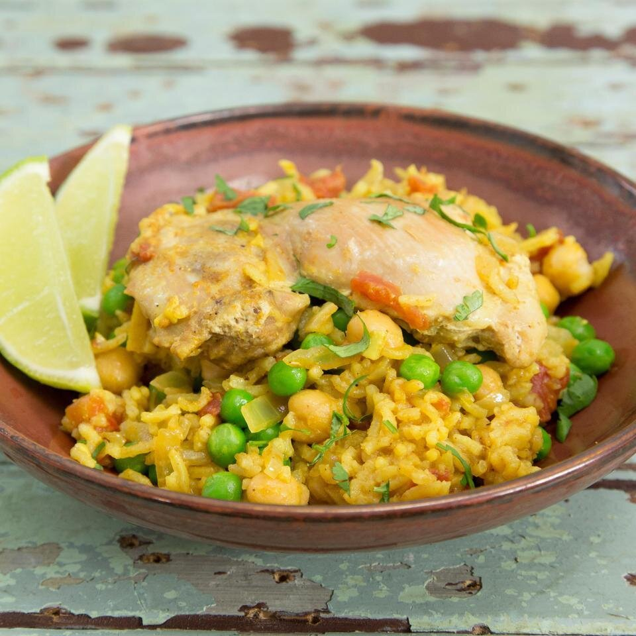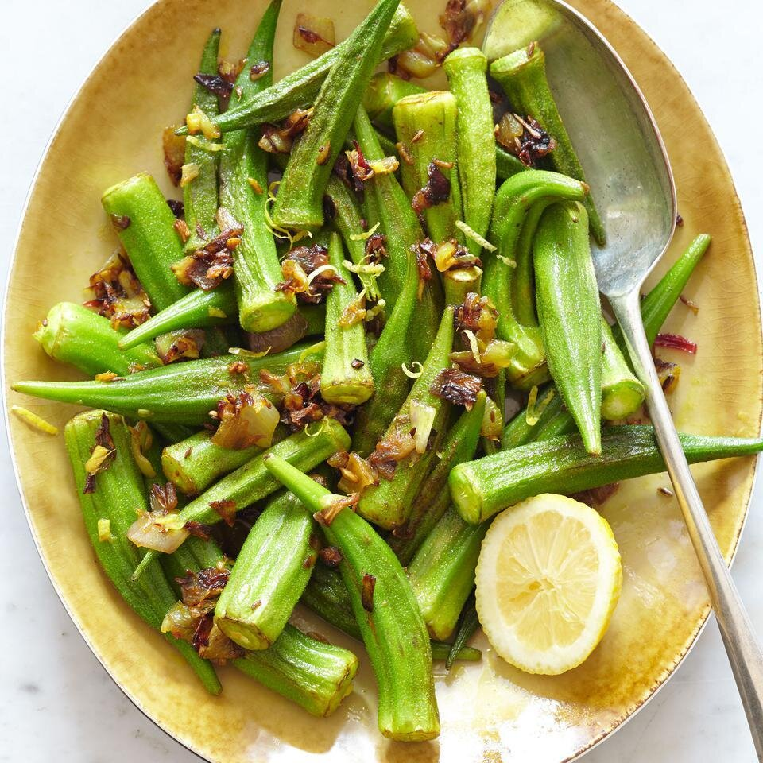

Brought to you by the
5K Walk/Run for Scholarships Wellness Program

Have you ever had healthy Chicken Curry and tasted fresh Okra? Do you want to learn how? Explore transforming your favorite dinner into a tasty healthy option while showcasing the season’s fresh ingredients. Join the Hospitality Department’s Chef Lannak in this In-Person and Hands-On cooking demonstration and cooking class to learn more.

Who? This event is open to all MCC employees

What? The Menu includes Chicken Curry over Rice and Indian Style Sautéed Okra

When? Wednesday September 29, 2021 from 5:00 p.m. to 6:00 p.m.

Where? MCC Hospitality Department kitchen: Building 3 Room 140

How? How much does it cost? The cooking class is FREE (thanks to the 5K
Walk/Run for Scholarships Wellness Program!)

Seating is limited to 15 participants and is on a first come, first served basis, so sign up early. Email Andrea Wolff at awolff@monroecc.edu for additional details and to register for the class.

For your safety in the kitchen, please wear covered-toed shoes with non-slip bottoms. Tennis shoes are great! Note that Masks are required.

