

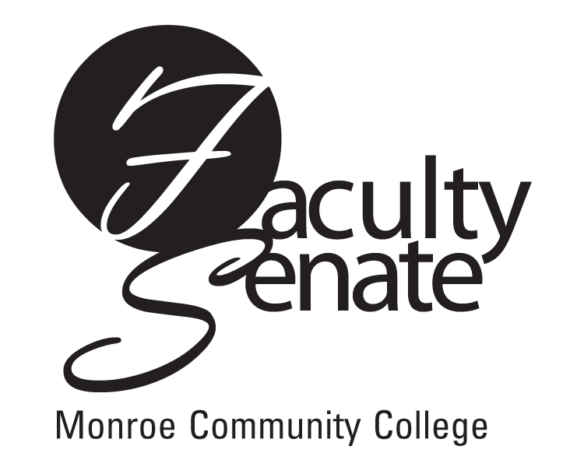 All College
Faculty Senate Agenda
Monroe A June 12, 2008
3:30 p.m.

1. Guest Speaker – President R. Thomas Flynn

- All College Meeting

3. Announcements

4. Approval of Minutes from May Faculty Senate Meeting

- Action Items:
Curriculum:
Program Revision:
PR5S Teaching Assistant – Technology, Certificate
PR6S Teaching Assistant Early Childhood/Childhood, Certificate
Academic Policies:
Resolution 1.2.1 – Advanced Standing Credit Proposal
Program Review Guidelines

6. Standing Committee Reports

7. Student Announcements

8. Old Business
Other

9. New Business
Other

