DISCOUNTS AVAILABLE
FOR THE SMASH HIT
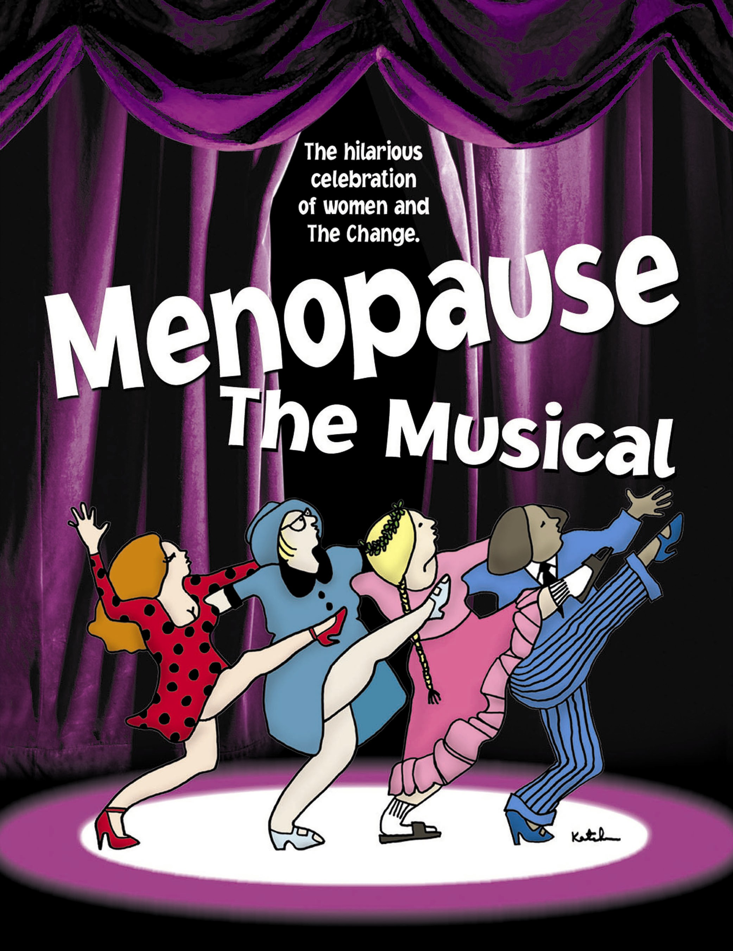

On Stage at Geva Theatre Center
July 7 – August 2
The Story: This musical comedy follows four women at a lingerie sale with nothing in common but a black lace bra AND hot flashes, night sweats, memory loss, not enough sex, too much sex and more. With guts and gusto, they sing their way through the challenges of "The Change" in a celebration of shared experience.
The Experience: This joyful musical parody set to 25 classic baby-boomer songs from "Puff, My God I'm Draggin'" to the disco favorite "Stayin' Awake, Stayin' Awake" will have you cheering and dancing in the aisles! It's definitely not "The Silent Passage" anymore!
The Buzz: This must-see show has turned into an international phenomenon.
“You’ll love it, it’s hilarious, go see it.” -- Joy Behar, The View
“It’s impossible not to laugh.” -- Liz Smith, The New York Post

“By all means, go and have a rollicking girls’ night out.” -- Boston Globe
Fine print: America's #1 Girls' Night Out!
You can order specially discounted tickets for Menopause, the Musical. Tickets to any performance are just $45.00 for Orchestra Seating, and $40.00 for Section B – Balcony ($5.00 discount). Performance times are Monday-Saturday evenings at 7:30 or Saturday matinees at 3:00. For more information or to order tickets contact Colleen Brown at 585-232-1366 ext. 3057 or email to cbrown@gevatheatre.org



