MCC Network Password Changes
The ETS Help Desk has received an increase number of calls from people whose network password is about to expire. If changing your password from off campus and using Outlook Web Access, be sure to click the ‘Change Password’ button after creating the new password. If you click the ‘Continue’ button, you will continue using the old password.
Another issue we have seen; people do NOT log off their office PC, they just lock the PC when they leave the office. They will not be prompted that their password is to expire in a set number of days. When the days run out their password will no longer work.
ETS would like to remind all faculty and staff the six month period for changing their network password has arrived for many people. Remember a strong password is MCC’s first line of defense against unauthorized access to network resources. You will be prompted when logging on, that your password will expire in a set number of days.
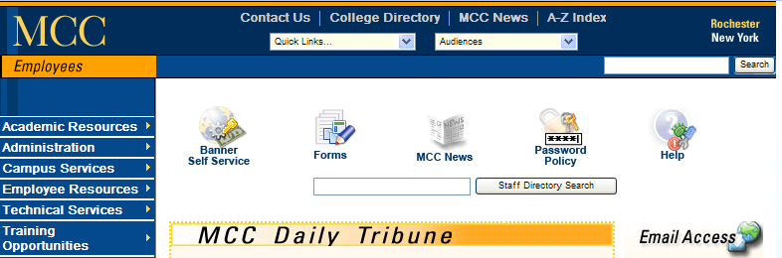

MCC’s Password Policy can be found by clicking the ‘Password Policy’ icon on the ‘Employees’ website. But here is a brief summary…
-- The new password must have 8 or more characters
-- Password cannot be reused. The system will remember the last 20 passwords.
-- Must have 3 of the following…
at least 1 upper case letter
at least 1 lower case letter
at least 1 number
at least 1 special character (#, *, =, etc.)

-- The password does not contain three or more consecutive characters from the user's name or the previous password.

Any questions, call the Call Center x4357 when on campus, or 292-2000 x4357 when off campus.

