

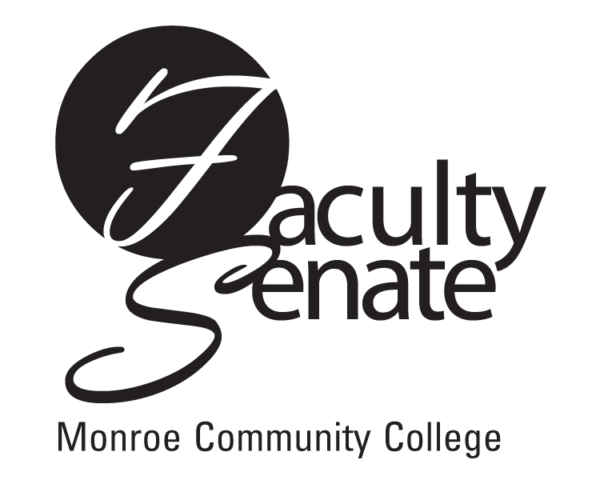 Faculty Senate Agenda
Warshof Conference Center
Empire Room
February 15, 2007
3:30 p.m.

- Announcements

- Action Items:
Academic Policies Resolution: 1.1.5.3
NEG Resolutions: 6.1.4(3) and 6.1.8
Curriculum: PD2F Public Administration, Certificate
PR8F Apprentice Training-Auto Toyota T-Ten, AAS
NP4F Addictions Counseling, AS

3. Approval of Minutes from January Faculty Senate Meeting

4. Standing Committee Reports

5. Student Announcements

6. Old Business
Other

- New Business
Other

