The Sociology Film Series Presents Two Special Events to Kick-Off the “Friends” DWI Exhibit

SPIN THE BOTTLE: SEX, LIES & ALCOHOL
Featuring Jackson Katz & Jean Kilbourne

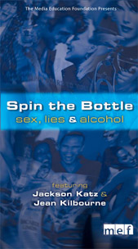

“By exploring the college party scene, Spin the Bottle shows the difficulties students have in navigating a cultural environment saturated with messages about gender and alcohol. Interviews with campus health professionals provide a clear picture of how drinking impacts students’ health and academic performance, but it is the students’ own experiences and reflections that tell the real story behind alcohol’s alluring public image” (from www.mediaed.org)

BRIGHTON CAMPUS: DAMON CITY CAMPUS:

Wednesday, October 15, 2008 Thursday, October 16, 2008

3:00pm-5:00pm (view film with 3:00pm-5:00pm (view film with
discussion to follow) discussion to follow)

R. Thomas Flynn Campus Center Room #4151 DCC
Room 3-205 Monroe A Sibley Building

These events are free and open to the public. Light refreshments will be provided and parking is available for a fee on both campuses. Please consult MCC’s website at www.monroecc.edu for details and directions. The “Friends” Exhibit will run from Oct. 15th-Nov. 24th on the Brighton Campus.

These Film Series events are co-sponsored by the Dept. of Anthropology/History/Political Science/Sociology, the Dean of Liberal Arts, Mike McDonough and Interim Dean of DCC Academic Services, Craig Rand.

Please direct any questions to Christine Plumeri, Sociology, 262-1768 and/or cplumeri@monroecc.edu.

