Registration & Permission Form

MCC Science & Technology Entry Program – National Society of Black Engineers Jr.

Project: Vision
MCC Damon City Campus - 228 East Main St., Room 5123

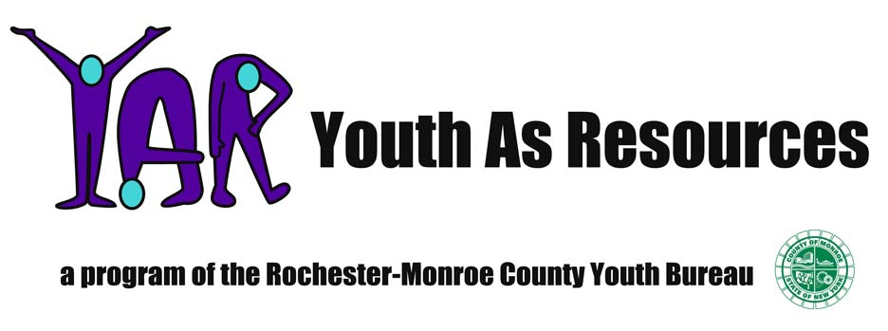
Friday, April 2, 2010
9:00 a.m. – 3:30 p.m.

*** Registration ***

Student Name (print): ________________________________________ School: ______________________________

Grade (circle one): 6 7 8 What do you want to be when you grow up? _____________________

Address: __________________________________ Phone Number: ______________________________________

Special Diet/ Food allergies: ___________________________________

*** Permission ***

I, ______________________________________, give my child, _______________________________________________,
(parent/guardian name) (student name)
permission to take part in Project: Vision at 225 East Main St. on Friday, April 2, 2010. I understand that the MCC Science & Technology Entry Program (STEP) and its staff will assume responsibility for my child when he/she signs into the program at the event site and will surrender responsibility for my child when he/she signs out of the event.
I also give Monroe Community College, YAR, and STEP permission to use the student’s name, image, voice recording, testimonial and/or information on the student in news releases, feature articles, advertisements, marketing and communication materials and other promotional efforts, as well as, publications in general and trade magazines, newspapers and other print, radio, television, electronic, video, or multimedia projects. I release all claims against Monroe Community College and STEP. I realize that the use of student information described above has no expiration date and may be used at any time without subsequent contact or approval. Should I not want publicity of the student’s image or information in the future, I must contact STEP or the Public Affairs Department of Monroe Community College in writing of such intent.

Emergency Medical Treatment
I also hereby appoint staff and chaperones of MCC STEP to act on my behalf on authorizing medical, dental, surgical, or hospital care for my child if I cannot be reached at the telephone number(s) listed on this form or if the emergency contact cannot be reached.
***Is there anything in your child’s medical history that should be known in case of emergency? Please note it here:

Parent/Guardian Signature: _____________________________ Date: ___________ Daytime Phone: _______________________

Emergency Contact Name: _____________________________ Emergency Contact Phone: ________________________________

FORM MUST BE RECEIVED BY APRIL 1st TO PARTICIPATE
Phone: 262-1688 * Fax: 262-1680 * STEP Program 228 E. Main St, Suite 5222, Roch, NY 14604

