Bring your research project and meet with a librarian or a writing tutor for individual or group consultations.

* Do you need help finding a research topic or sources?
* Do you want help with your writing or need assistance with citations?
* Do you want assistance formatting your document?

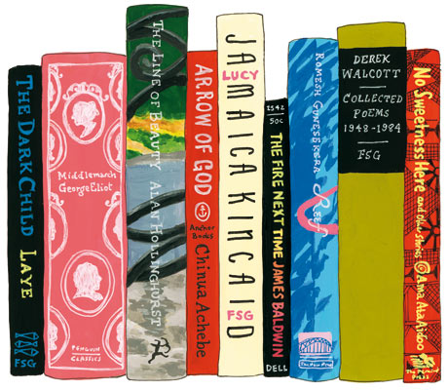  

**Date**: Monday, November 10, 2014

**Time**: 12:00 noon (college hour)

**Location**: Building 2- Room 423 in the library

**Contact Info**: Jean McDonough at 292-3360 or [jmcdonough@monroecc.edu](mailto:jmcdonough@monroecc.edu)

Alice Wilson at 292-2304 or [awilson@monroecc.edu](mailto:awilson@monroecc.edu)

**The MCC Leroy V. Good Library & the Writing Center Present:**

**A Research Paper Clinic for Students**

