FLAC FILM FESTIVAL
The Edge of Fantasy
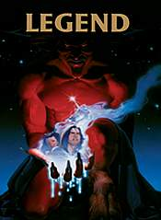
LEGEND
Directed by
Ridley Scott
December 14th
6:00pm
12-229
Presented by
Prof. Heather Williams

The last in the 2006 Fall Film series!
Come for the film, stay for the discussion!

Sponsored by FLAC
(The Fantastic Literature and Arts Collective)

Pizza and refreshments provided
Website: http://web.monroecc.edu/FLAC/

