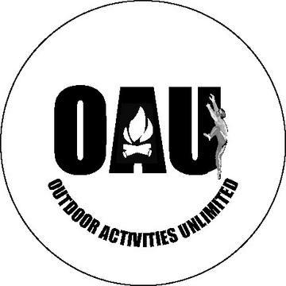
OAU

Outdoor Activities Unlimited Club

Rochester Enjoy The City Coupon Books
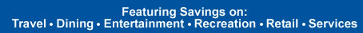

More than $1000 in value
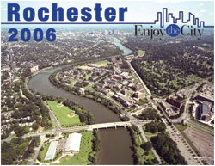

2 Books For Only $25 or
1 Book for $15

Make Checks Payable To: MCC Association Memo: MCCOAU

Sale Through: December 9th
See Back For All The Great Merchants
Restaurants
58 Main Restaurant & Party House
Abyssinia Restaurant
Alexandria Mediterranean Cuisine
All Star Pizza
Arby's
Auntie Anne's
Baxter's Radisson
Bellanca's
Best Burger
Bill Gray's
Blimpie Subs & Salads
Brad's Cookie Nook
Brighton Donuts
Brownsteins Deli & Bakery
Burger King
California Rollin' Sushi Bar
Carmine's Family Restaurant
Cava Cori's
Charley's Grilled Subs
Chasers Sports Bar & Grill
China Gate
China Moon
Choo Choo's Express Restaurant & Dinosaur Train Ride
Cibon
Cindy's Cinnamon Rolls
Coleen's Café
Corky's Craving Parlor
Crystal Palace Family Restaurant
Dario's Famous Pizza II
Davinci of Greece Italian Restaurant
Desert Moon
Domino's
Don's Original
Dribbles Sports Bar
Dunkin' Donuts
Earthtones Coffee House
El Pacifico
Erie Canal Bar & Grill
Flour City Diner
Food For The Mind
Glengarry Grill
Godfather's Pizza
Golden Ponds
Golden Port
Good Fella's Pizzeria
Good Guys Pizza
Gourmet Pizza
Gregorio's Pizza & Restaurant
IHOP
India Café Restaurant
India House Restaurant
Java Junction Coffee Roasters & Bakery
Jimmy Mac's Bar & Grill
Keenan's Restaurant
Krispy Kreme Doughnuts
La Trattoria d'Abruzzo Italian Ristorante
Leadbelly Landing at the Beach
Lickety Split
Lift Bridge Café
Maoria's The Bay Bar & Grill
Marie's Ristorante
Michelina's Italian Eatery
Ming's Noodles II
Napa Gino's
Nick's
Nola's BBQ
Northlands Bar and Grill
O'Malley's Irish Sports Pub
On The Rocks NY Grille
Orange Julius
Overtime Sports Bar & Grill
Palermo's Subs
Palladio Restaurant
Papa John's
Parkside Diner
Peeking Duck Chinese Restaurant
Pizza Hut
Plum Garden
Popeyes Chicken & Biscuits
Portobello Ristorante
Posella's Pizzeria
Pucket Thai Cuisine
Quiznos Sub
Raj Mahal
Richmond's - Rochester's Neighborhood Bar & Grill
Ridge Donut Café
Rosey's Italian Café
Russell's Ice Cream
Sand Trap Grill at Mulligan's Pub
Schoen Place Prime Rib & Grill
Shanghai Chinese Restaurant
Shells' Pizzeria
State Street Bar & Grill
Subway
Sullivan's Charbroil
Summerville Grill
T. Brennans Saloon & Catering
TC Hooligans Bar & Grill
The Argyle Grill
The Duchess
The Gallery Restaurant Lounge & Party House
The Greenhouse Café
The Lunch Box Spot
The Newport House
The Oak Leaf Eatery
The Old Toad Authentic British Pub
The Original Pineapple Jack's
The Original Rick's Prime Rib House
The Reunion Inn
The Scotch -N- Sirloin
Thirsty Turtle Sports Bar
Tokyo Japanese Restaurant & Hibachi Steak House
Tom Wahl's
Tully's
Two Paisans Pizza
Waldron's Café
Wilshire Restaurant & Catering
Wimpy's Burger Basket
Yumbo's Southern Style Deli
Entertainment/Recreation
AMF
Bowl-A-Roll
Clover Lanes
Memorial Art Gallery
Nazareth College
Rochester Americans Hockey Club
Rochester Knighthawks
Rochester Museum & Science Center
Rochester Philharmonic Orchestra
Rochester Raging Rhinos
Seneca Park Zoo
Spinner's Family Fun Center
The Clubhouse Fun Center
The Susan B. Anthony House
Golf
Auburn Creek
Chili Country Club
Eagle Vale
Executive South Family Golf Center
Par Busters Golf Driving Range
Riverton Golf Club
Southern Meadows
Sportworks Miniature Golf Rules
The Golf Tee
Retail/Services
Buckmans Car Wash
Delta Sonic
Dorrens & Watts Cleaners
Enterprise
Evergreen Car Wash
F.Y.E.
Foot Locker
FTD.COM
Getty Home
Klee Car Wash
Li Mura's Custom Tailor
Lilac Laundry
Monroe Muffler/Brake & Service
MovieClub Online.com

