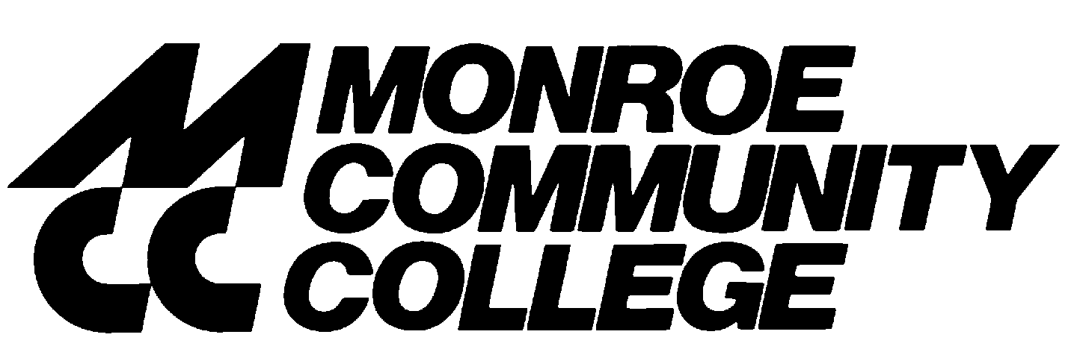

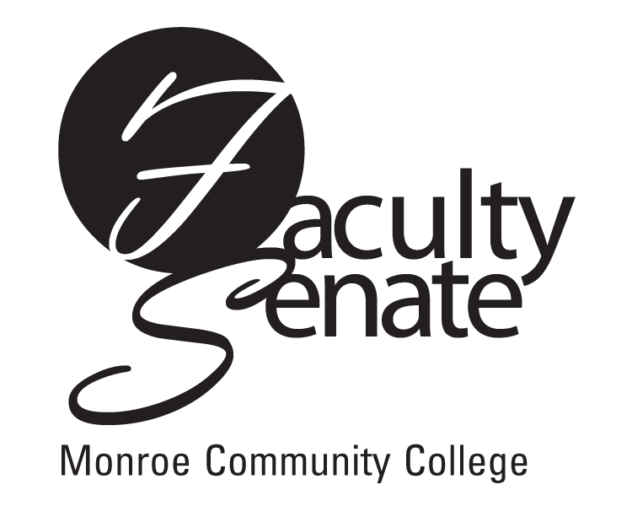 All College
Faculty Senate Agenda
Monroe A June 10, 2010
3:30 p.m.

- All College Meeting

- Guest – Lee Struble – Presidential Forum on Campus Civility

- Announcements

- Student Announcements

- Approval of Minutes from May Faculty Senate Meeting

- Action Items:
Curriculum:
Program Revisions:
PR14S Visual Communication Technology: Graphic Arts/Printing, AAS
PR 21S Public Relations, AS
New Programs:
NP2S Interdisciplinary Humanities, AA
NP3S Clinical Laboratory Technician/Medical Laboratory Technician, AAS

Vote on Gen Ed Definitions and Outcomes

- Standing Committee Reports

- Old Business
Other

9. New Business
Other

