

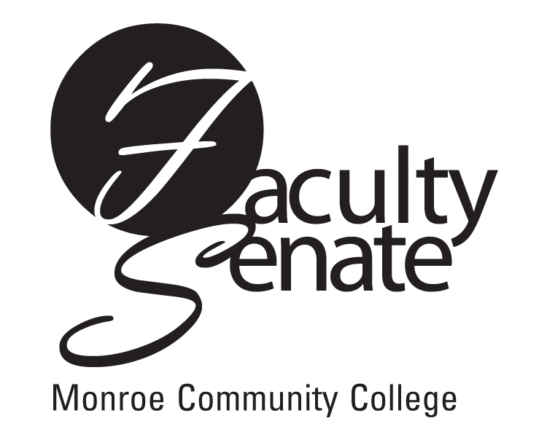 All College
Faculty Senate Agenda
5-300 June 4, 2009
3:30 p.m.

- Guest Speaker – Dr. Larry Tyree, Interim President

- All College Meeting

- Announcements

- Approval of Minutes from May Faculty Senate Meeting

5. Action Items:
Resolution of Restored Confidence in the MCC Board of Trustees
Academic Policies – 2011-2012 Academic Calendar

- Standing Committee Reports

- Old Business
Other

8. New Business
Other

