“
“Enriching
Advisement:
The
Workshop
Series"
In June
Here is an opportunity
to take 2 advisement workshops back-to-back and be our guest for LUNCH!!!

SAVE THE DATE:

June 4, 2010

8:30 am – 1:00 pm
(Lunch provided: 12:00 –
1:00 pm)

Workshop choices will be out soon….

Denise Klein (2295),
Kathy O’Shea (3339),
Jennifer Kinslow (2297)

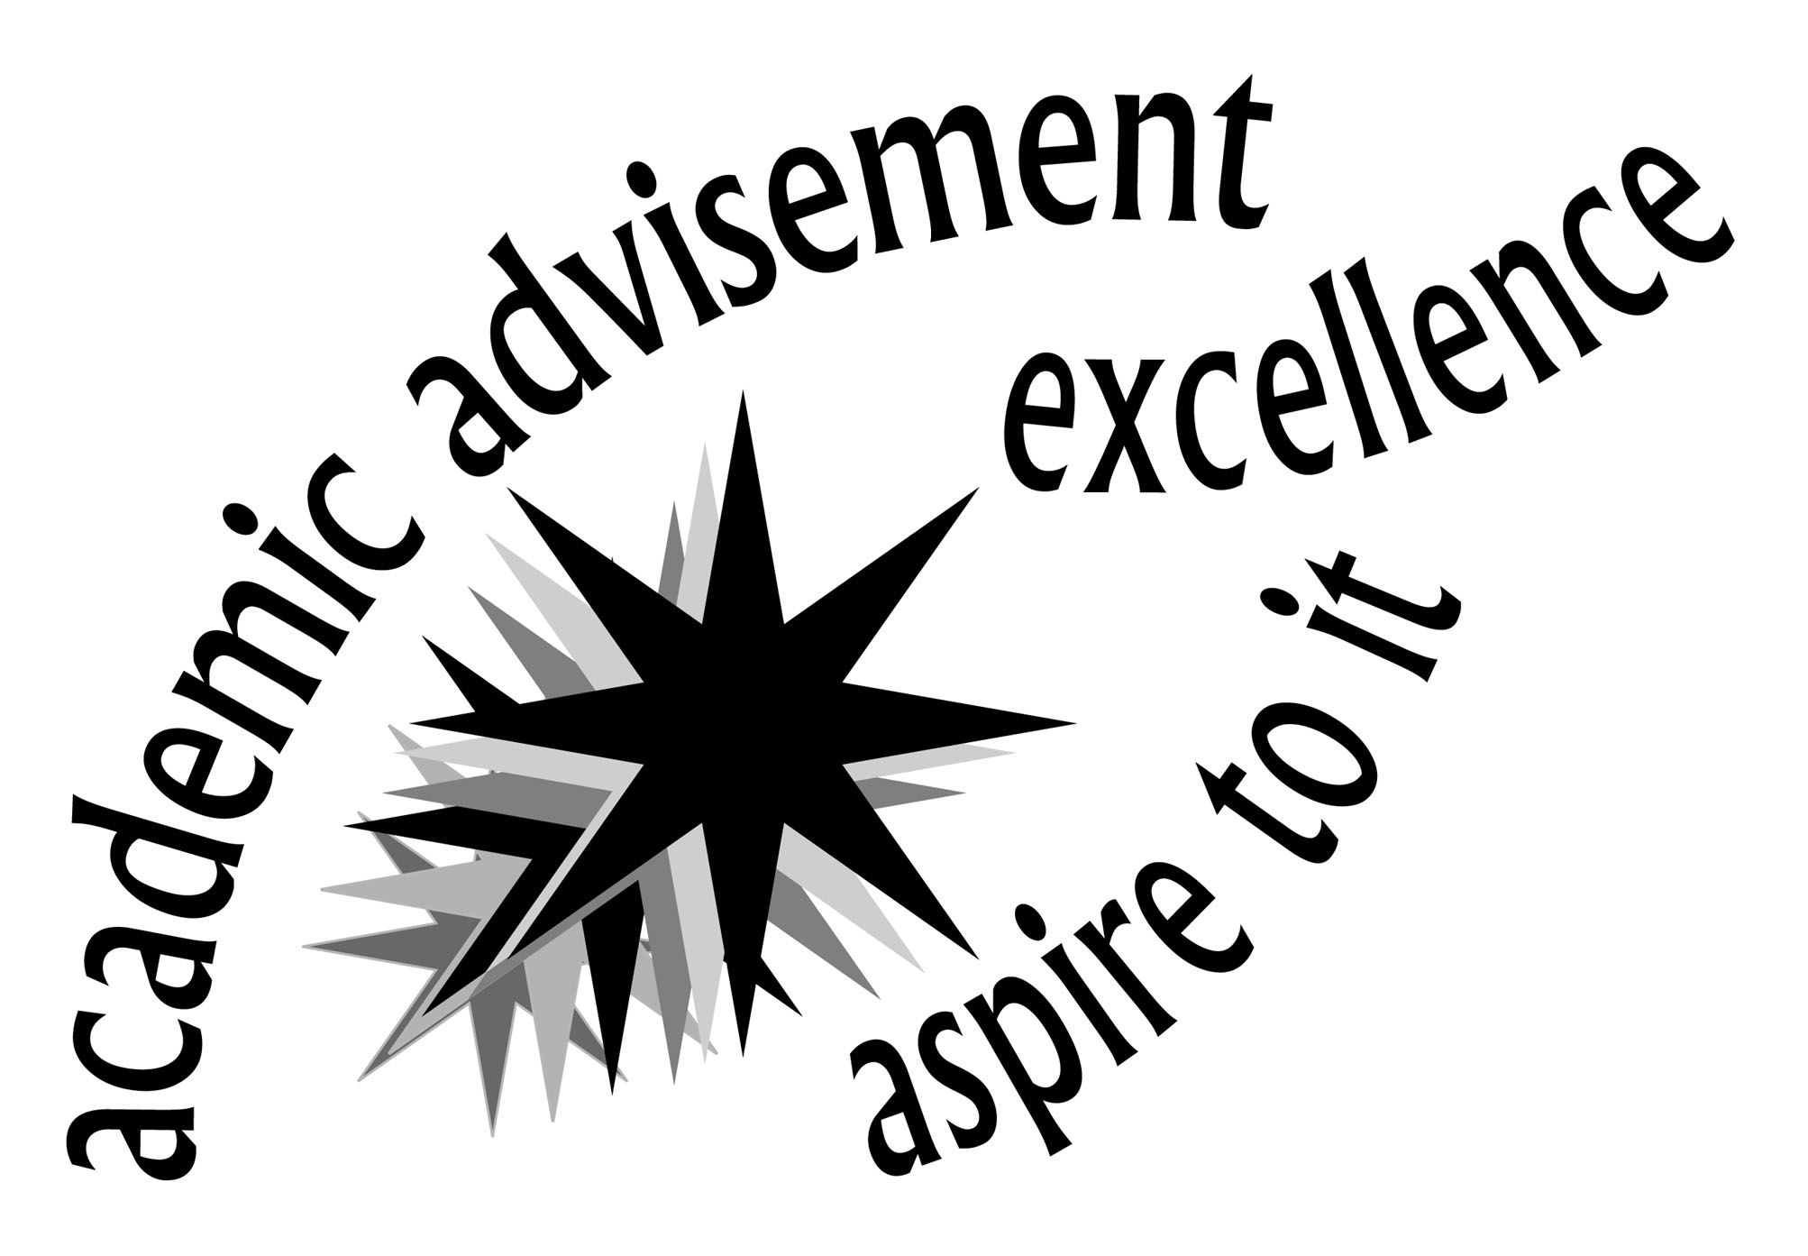

“Knowing is not enough, we must apply.
Willing is not enough, we must do.”
--Goethe

