To install the SonicWALL Junk Button for Outlook and disable your Outlook Junk Folder, please perform the following steps:

- Close Microsoft Outlook if it is currently open.

- Click \\MCC-CONFIGMAN\Packages\junkbutton.msi

- Click Open on the Opening Mail Attachment window.
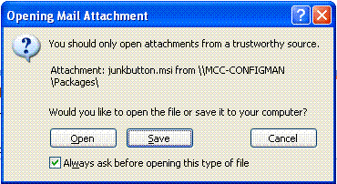

- If prompted with a Security Warning, click Run.
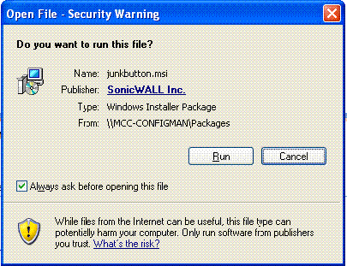

- Click the Next button three times to begin installation.

- Click Close once the installation is complete.

- Open Microsoft Outlook.

- Click the Tools menu and select Options.

- Click Junk Email from the Preferences tab.
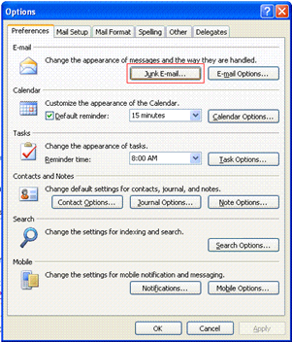

- Select No Automatic Filtering.
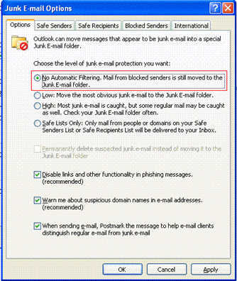

- Click OK twice to return to Microsoft Outlook.

At this point, your Outlook Junk Folder has been disabled, and a Junk button has been added to your Outlook toolbar.
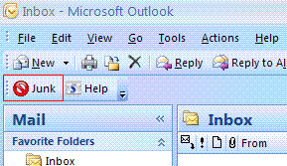

If you receive a junk message, simply click on the message and then click the Junk button. The message will be automatically deleted, and the details of the message will be submitted to SonicWALL so the message signatures can be used to make the filtering system more accurate.

