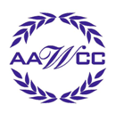
Thank you!
Your generous donation of clothing, shoes, and/or accessories will be given to the Volunteers of America to assist men and women in our community!

Volunteers of America helps more than
10,000 people throughout Western and Central New York each year. Its mission is to enable people in our community to break the cycle of poverty and reach their full potential.

Gently used children’s clothing will be sent to:
Touch of Love and Guidance
Spring Clothing Drive
at Monroe Community College
April 25 - 29, 2011

Brighton Campus
Monday through Friday
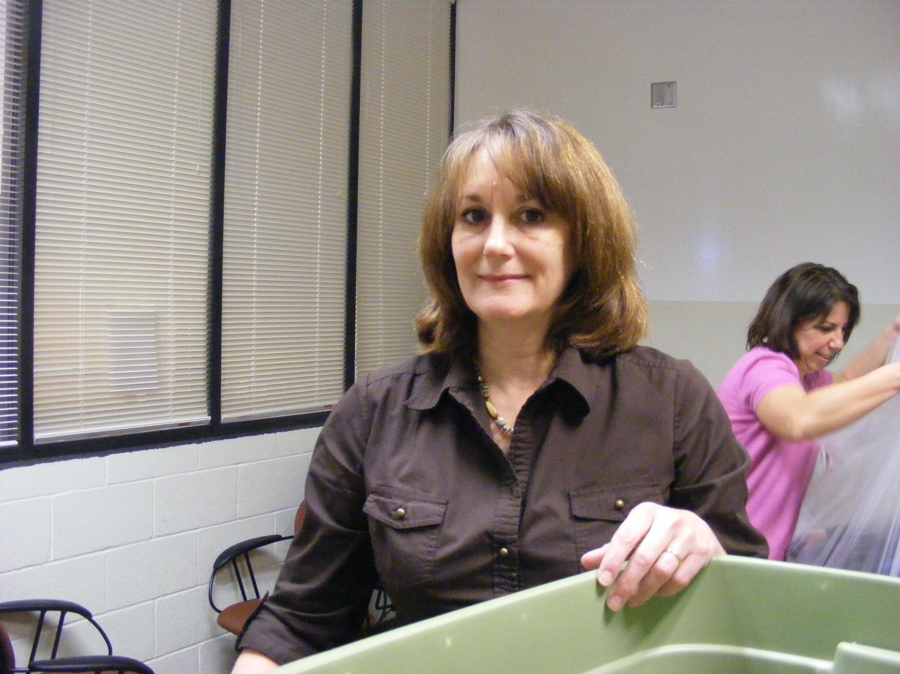
11:00 am to 2:00 pm
Room 3-113

Damon City Campus
Contact Vilma Morrow
or Christine Plumeri
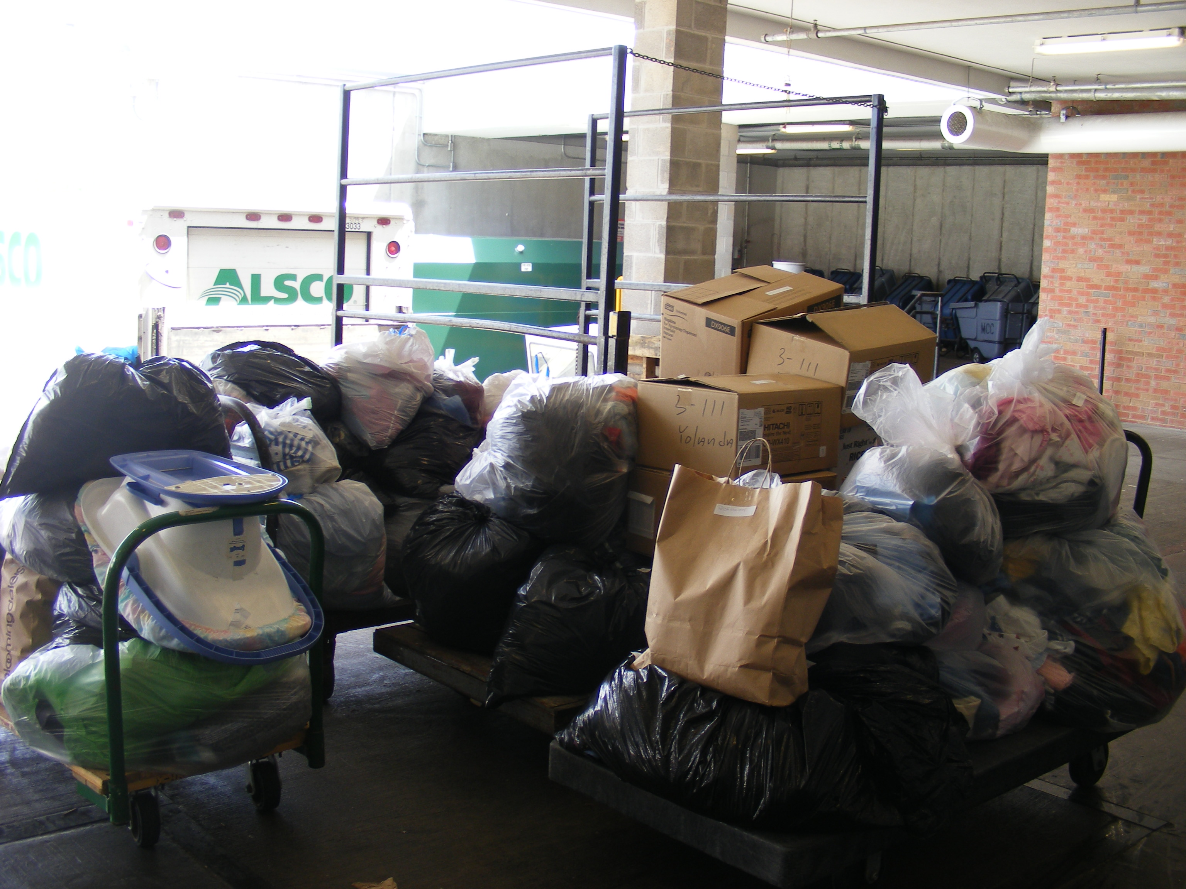
Student Services Center, Room 4216

Applied Technologies Center
Contact Kristi Graves, Room 158

Public Safety Training Facility
Contact Marjorie Scahill, Room 216F

Need special arrangements?
Please call Gale LePore at 2199.

If you need to drop off during a different time period, see Courtney Belluccio in Campus Events.

