Attention Blackboard users
!!!!! Exciting News !!!!!

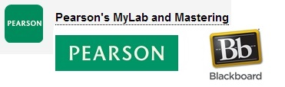

MCC now has single sign on capabilities with:
Pearson’s Mylab and Mastering

Documentation is available in Bb Babblings
or
Pearson’s online documentation
or
Blackboard’s online documentation

.. Instructional Development Team – May 2, 2014 ..

