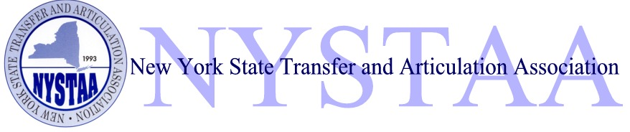

Scholarship Application
2012

NYSTAA Mission Statement
The New York State Transfer & Articulation Association is an organization dedicated to establishing a state-wide academic forum and support group for transfer issues.

NYSTAA Scholarship
NYSTAA will be awarding four (4) scholarships valued at $2,000 each

Guidelines for applying:

- Have completed an Associate in Arts, Associate in Science or Associate in Applied Science by August 2012 from a two-year member college*
- Have a minimum cumulative grade point average of 3.2
- Apply and plan on attending a four-year member institution*
- Complete the attached application and present all required criteria

Please provide the following:
- Completed scholarship application
- Official transcripts from all colleges attended and courses in progress (if applicable)
- One letter of recommendation from a college administrator or faculty member
- Essay

Deadline for applications:
March 1, 2012

Tear off and return the application page and credentials to:
Michelle Delaney
Pace University
Office of Admissions
861 Bedford Road
Pleasantville, NY 10570

If you complete the application on the web site, email to:
mdelaney@pace.edu

*For a list of member institutions visit the NYSTAA web site at www.nystaa.org and select Member Institutions on the side bar. Note: Only New York State member colleges/universities qualify.

NYSTAA 2012 Scholarship Application
(Please type or print)

Name _____________________________________________________________
Address _____________________________________________________________
_____________________________________________________________
Phone _____________________________________________________________
Email _____________________________________________________________

Name of Two-year College: _______________________________________________
GPA: _______________________ # Credits to date: _____________________
Degree: AA/AS AAS Date of Graduation: _____________________
Other College(s) attended: _______________________________________________
_______________________________________________
List College(s) applying to: _______________________________________________
_______________________________________________
Intended Major: _______________________________________________

Recommendation
Please give the name of the person who will be providing a letter of recommendation: Name:_______________________________ Title:__________________________________

Essay
On a separate sheet of paper, please write an essay indicating your educational plans and how they will fit into your career goals.
Honors/Awards Dates
_____________________________________________ _________________
_____________________________________________ _________________
_____________________________________________ _________________

College/Community Involvement Dates
_____________________________________________ _________________
_____________________________________________ _________________
_____________________________________________ _________________
Work Experience Dates
_____________________________________________ _________________
_____________________________________________ _________________
_____________________________________________ _________________
(May attach a sheet with additional honors & involvement or a Resume)

I certify the information in this application is true. Additionally, I give permission to NYSTAA to use the information submitted, including the essay in its publications & web site for publicity and future scholarship brochures.

Signature____________________________________ Date ____________________

What is NYSTAA?

The New York State Transfer and Articulation Association is an organization formed to help promote ease of transfer and to encourage professional development of its members. Membership is open to professionals involved with the transfer process who work for any Middle States accredited higher education institution within New York State. Associate membership is available to individuals of higher education outside New York State.

NYSTAA Scholarship Definition

The New York State Transfer and Articulation Association Scholarship is a monetary award given to student’s graduating with associate’s degrees from member two-year colleges and transferring to member four-year institutions, both in New York State.

NYSTAA Scholarship Committee
Questions or more information contact:

Gail Akin, SUNY College at Oswego (akin@oswego.edu)
Chris Belle-Isle, Monroe Community College (cbelleisle@monroecc.edu)
Michelle Delaney, Pace University (mdelaney@pace.edu)
Paul Fisher, Cornell University (psf1@cornell.edu)
Marian Nicoletti, Rochester Institute of Technology (mmnadm@rit.edu)
Heather Stevens, Tompkins Cortland CC (stevenh@sunytccc.edu)
Lynn VanZandt, Nazareth College (lvanzan6@naz.edu)
Mark Wojnowski, Niagara University (mew@niagara.edu)

The NYSTAA website can be located at www.nystaa.org

The New York State Transfer and Articulation Association is a nonprofit organization dedicated to transfer issues and transfer student educational opportunities and does not discriminate against race, creed, age, gender or lifestyle in membership or scholarship candidates.

