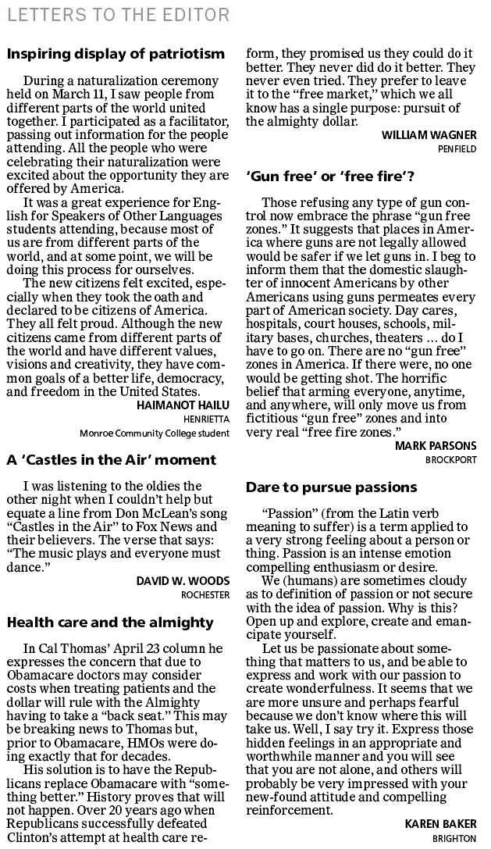

**ESL 100 Student  
Spring 2014**