CREATING A PURCHASE REQUISITION IN FY-08
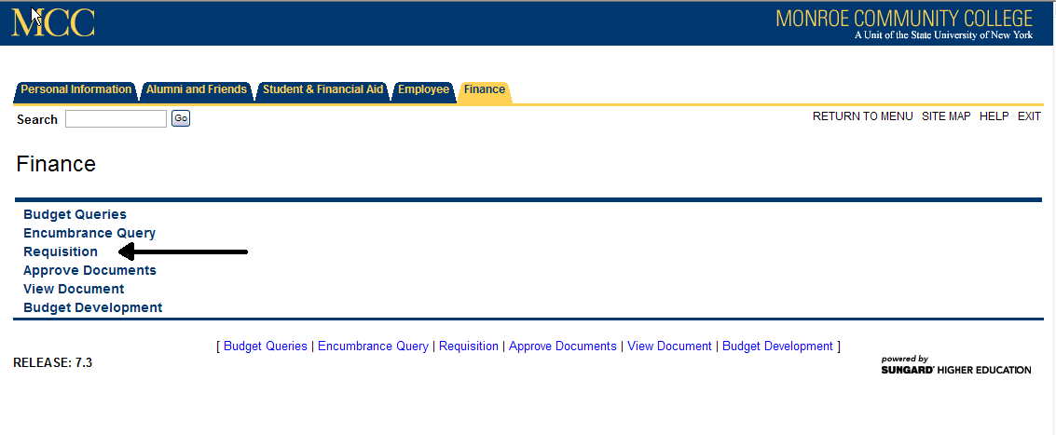
Navigate to options screen in Banner Finance Self Service and Click on ‘Requisition’

Changing the dates on the Requisition:
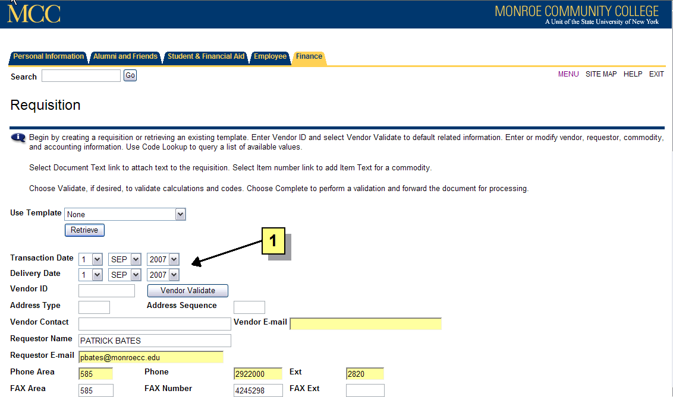

1 The ‘transaction date’ and ‘delivery date’ will always default to the current date. When creating a requisition in August for the FY-08 budget, the ‘transaction date’ and ‘delivery date’ must be changed to September 1, 2007 or later.

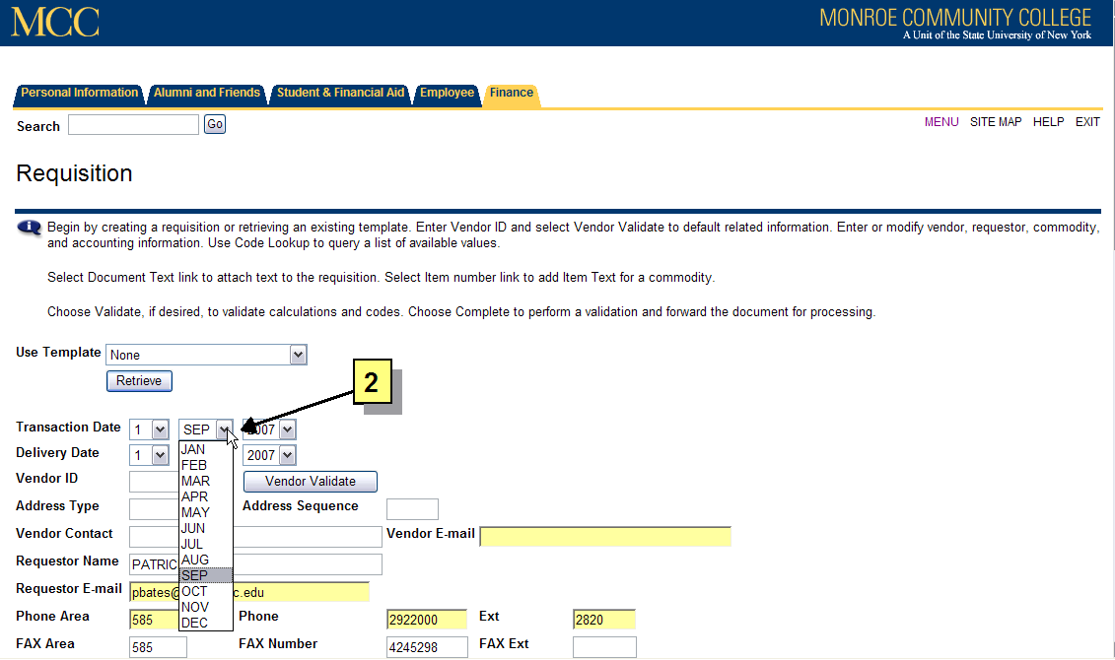
2 To change the date and month, simply click on the appropriate arrow which will open a box containing valid values. Select the correct values to make both the transaction and delivery dates September 1, 2007 or later.

IMPORTANT NOTE
Failure to change the dates to September 1, 2007 or greater, will prevent your requisition from being processed. Purchasing staff members will review dates on approved requisitions. If the staff discovers date errors, the requisition will be deleted, and the requestor will be advised to complete a new requisition. Please contact Purchasing immediately if you realize you have completed a requisition with the incorrect dates, a staff member will remove it from the system.

